CSUDH-Logo-Email-Signature

Academic Senate •1000 E. Victoria • Carson, CA 90747 • WH-A420 • (310) 243-3312

**Academic Senate Meeting Minutes**

**April 10, 2019/Loker Student Union/2:30 – 5:00 PM**

Voting Members Present, Benavides Lopez, Bono, Chhetri, Dixon, Evans, Hirohama, Johnson, Kalayjian, Keville, Kitching, Krochalk, Kulikov, Laurent, Ma, McGlynn, Mendoza Diaz, Monty, Naynaha, Park, Pawar, Phan, Pong, JPrice, Sanford, Sharp, Silvanto, Skiffer, Tang, Taylor, Yi

Voting Members Not Present: Andrade, Cutrone, Deng, Ernst, Fortner, Gray-Shellberg, Heinze-Balcazar, Jarrett, Macias, Morris, Nicol, VPrice, Radmacher, Still

Voting Ex-Officio Members Present: Celly, Esposito, Gammage, Joseph, Norman, Ortega, Parham, Ospina, Talamante

Voting Ex-Officio Members Not Present: Pinto

Non-Voting Ex-Officio Members Present: Avila, Costino, Davis, LaPolt, O’Donnell, Wen

Non-Voting Ex-Officio Members Not Present: Brasley, Driscoll, Franklin, Goodwin, Manriquez, McNutt, Peyton, Poltorak, Sayed, Spagna, Stewart

Guests: T. Caron, E. Cleek, J. Hill, D. Parker, G. Polk, H. Salhi, D. Roberson Simms, L. Wilson

2018-2019 Academic Senate Executive Committee:

Laura Talamante – Chair, Kate Esposito – Vice Chair, Justin Gammage – Parliamentarian, Dana Ospina – Secretary, Enrique Ortega – EPC Chair, Katy Pinto – FPC Chair, Kirti Celly and Thomas Norman – Statewide Senators

**Recorded and Edited by SEW and the Executive Committee**

Meeting Called to Order: 2:30 PM

Approval of Agenda M/S/P

Approval of Amended Minutes (Senator Skiffer noted she had attended the 03/20/19 however current minutes state she had not. Noted, minutes would be amended. Minutes: M/S/P

**Academic Senate Chair Report: (which was provided via handout)**

* **Senate Elections** – Our Parliamentarian has been working to resolve the technical issue with the election and has finally come to a resolution. After consulting IT, the best option is to relaunch the election but send ballots through the Senate Parliamentarian email. The university has made changes to address spam issues, which they believe is causing the high number of bounced back emails (voters not receiving their ballots). Due to the ballots being sent through Survey Gizmo, a third party entity, our university email system identifies the emails as spam and are denying the emails. Thus, he will close the election module and redistribute the ballot via the Parliamentarian email. Thus far, there has been a low response rate for each election: Academic Senate Chair - 9, Non-tenure track Rep –25, and Staff Rep - 1. Therefore, those who have cast their votes must revote. Please let Justin Gammage ([senateparliamentarian@csudh.edu](mailto:senateparliamentarian@csudh.edu)) know if you have any questions or concerns.
* **Free Speech Week** - Thank you to Dr. Brooke Nelson for her fantastic organizing skills in bringing this rich and varied week of events to fruition. Thank you to President Parham and ASI President Christian Jackson for their collaboration with Senate to support our first annual Free Speech Week. Thank you to Provost Spagna for the financial support and allowing Dr. Nelson to dream big. And finally, thank you to Ms. Aly Hudspeth in Ceremonies and Events, Ms Susanne Walker, and everyone who volunteered this week!!
* **Statement on Shared Governance** – The President has agreed to work with the Senate Executive Committee and the Provost on a “Statement on Shared Governance” for inclusion in the Senate Handbook that is currently under development. A first version of the handbook should be completed by the end of the spring semester. The plan is to work with the President and Provost in our July Senate Exec Retreat and bring a draft for comment to the Senate in the fall retreat.
* **PTEs** - Starting April 15th, student evaluations will be administered, and faculty and students will receive three reminders between April 22nd and May 10th.
* **Senate Interns** – Over the past 6 weeks, we have had two Senate interns from Dr. Maria Avila’s Social Welfare Policy class who chose to learn about policy processes and outcomes via the work of the Senate. The two Master’s students have sat in on various Standing Committee and Senate meetings to learn about the development of resolutions, worked briefly in Academic Affairs to learn about the process from resolution to policy, and assisted in the Senate office on the evolving database of those participating in Senate service. Ms. Walker has supervised the students, and we all agree that it has been a beneficial experience. We are discussing the prospect of even creating a Senate internship as a permanent opportunity for students. The Senate internships garnered the attention of student reporter, Jordan Darling, who included the experience as part of a story in the CSUDH Bulletin on March 7, 2019 <http://www.csudhbulletin.com/getting-a-taste-of-administration-and-public-policy/>

**Senate Parliamentarian Report**

Parliamentarian Gammage explained that the structure of the election at the previous Senate meeting neglected to offer up a tenure track faculty member as well as a no- tenure track faculty member for the Gender Equity Task Force. Election was reheld with a new ballot. Ballots were distributed. They did receive only 1 non-tenure track person to serve as a Non-Tenure Track Faculty member of the Gender Equity Task Force, Asma Said. Her self-nomination was affirmed. Gammage said other business included three elections going on: staff representatives of the Senate, non-tenure track faculty and for the Senate Chair. At the time of the meeting there had been technical difficulties with the ballots of which Gammage was working through and would be active shortly. Senator Evans asked Parliamentarian Gammage if the election would be done over given there were technical difficulties. Gammage responded that the faculty election for the non-tenure track senator went off without a hitch, and so they would continue and end on Monday, the staff election and the Senate Chair election would resume on Thursday and end the following Wednesday.

**Second Reading:**

**EXEC 19-06 Resolution for the Creation of a CSU GE Program Review Subcommittee, Statewide Senator Thomas Norman**

Norman noted that this resolution was our campus’ attempt to look at what at statewide is one of two choices before the AS of the CSU. One of the current choices is to receive the GE Report and not make any recommendations, the other option was to create a subcommittee to complete the report but to consider the work unfinished. CSUDH has already passed a resolution encouraging rejection as has five other campuses since we last met. We’re not sure which of the outcomes is going to get passed at the final plenary in May. Norman asked if there was any input from the floor speaking in favor, against or offering any amendments to the resolution. Senator Monty said he was unclear as to the objective behind this resolution. Monty asked if in Statewide, the two options discussed at the last Statewide Plenary were one to reject and one to receive? Norman responded that no the rejection does not have enough play and that what our resolution mirrors is the closest rejection that is being considered. Monty asked if it had been voted on already? Norman said no, they’ve only been discussed in First Reading and the body asked the two sides go come together in a compromise if possible for the next plenary. Monty said he found that interesting given that we were up to what he believed were 10 campuses in the system who voted to reject. He does believe that any compromise solution has to emphasize that there are very strong sentiment from numerous campuses across the system that that report be rejected. Monty asked if the rationale could be amended in some way to make that point. He said at this point there is no reference to it whatsoever and wondered what would prevent any body convened in alignment with this resolution from just picking up the GE Task Force Report? Monty asked if Norman could clarify any more than what was said? Norman responded he could clarify from where he stood as a representative. He said he was a member who voted to reject as a member of the Faculty Affairs Committee and former Chair of it. He said they routinely get outvoted by the other two committees and Chair Filling and members are looking at options other than accepting. This was a creative idea on how not to accept it but to pull some other votes saying we can appreciate people working and thinking about it but we don’t want to at all empower that report. He said as a campus, it’s a difficult one for us to work on, because it’s really a behind the scene conference committee approach and he said he’s never been party of a campus weighing in on. He said he’s not aware of any other campus debating this. He noted it’s the nature of compromise, there’s nothing set. There’s the accepting votes and the rejection votes. Faculty Affairs isn’t in love with this idea, the sentiments are very much like our sentiments and the 10 other campuses you site. **Norman** continued that another option that CSUDH might want to consider is whether or not they want to table it and perhaps after the April virtual meeting, which has more information and which may lead us and Senate Executive Committee to make additional changes to the rationale rather than trying to amend from the floor. Monty recommended tabling because he said in the meantime our two statewide senators understand very clearly how this body and this campus would want them to vote on this issue, so he’s not sure that it is necessary that this body pass a resolution endorsing this alternative. There was a second in favor of tabling. The question was called and the Parliamentarian put tabling the resolution to a vote by a show of hands. Motion to table passes by a vote of 24 in favor, 0 against and 9 abstentions.

**First Reading**

**EXEC 19-07 Constitutional Amendment, Parliamentarian Justin Gammage**

Gammage made a motion to bring the resolution to the floor, which was seconded. He said the resolution was designed to update the constitution for the Academic Senate and in the spirit of shared governance to be more inclusive by including Non-Tenure Track Faculty on the Senate Executive Committee and having representation in the Senate from the Coaching Faculty.

**Senator Kalayjian** pointed out that in line two a typographical error where it states the election of “one” but in parenthesis it has the number two. **Talamante and Gammage** noted it should read (1). Senator **Celly** said that in writing the resolution they did not distinguish between Non-Tenure Track representative faculty line 19 and throughout. Non-tenure track instructional faculty member. It could be non-tenure track counseling faculty, non-tenure track hybrid faculty, non-tenure track coaching faculty, or non-tenure track instructional faculty. She said she’s happy with the way that it is but wants to clarify that that’s inclusive of all of the units. **Talamante** repeated just to clarify that it’s inclusive of all of the non-tenure track faculty, wherever their appointment is on campus. **Senator McGlynn** said as he understands it that non-tenure track faculty can be in any position within Senate Executive Committee. In theory all of current Senate Executive Committee could be non-tenure track faculty members? He wasn’t sure if maybe this could go even further, but he wasn’t sure how given that non-tenure track faculty represents the majority of faculty on campus. **Chair Talamante** said when at the AAUP conference in March, this was a suggestion that had come up and been put in place at another CSU. They thought it was a great idea for guaranteeing that there would always be a non-tenure track faculty member voice on the Senate Executive Committee to build upon the positive changes we’ve been making on campus. **Gammage** said if you currently look at the Senate Executive Committee there isn’t currently a non-tenure track faculty that’s part of the Senate Executive Committee, but also the same argument could be made about the Senate in general. Every Senator could be a non-tenure track faculty member. He said that it is to ensure at least one non-tenure track faculty member is present on the Senate Executive Committee. **Norman** said that the part that they removed from the changes to the constitution was trying to add an administrator to the Senate. The issue they had where they didn’t bring it forward was the definition of cabinet, it wasn’t clear enough. Norman said he still wanted to voice his support that in the future this body consider increasing and include members of the Cabinet to the voting body. He added it is not unprecedented on other campuses. He said he is not proposing an amendment at this time, maybe next years’ Senate or next years’ Senate Chair may want to have a conversation about expanding our inclusivity. **Senator Pawar** asked if the Senate Executive Committee planned to give this person release time or compensation? Is it equal to the amount of work that other members of Senate Executive Committee do and receive compensated for? **Chair Talamante** responded we’ve addressed this already with the Provost and the Vice Provost. Currently we have a tenured faculty member who is co-chair of the NTTTF Committee and at Senate Executive Committee we decided that this would be a good role for the incoming NTTF if this is passed and the General Faculty folks support it as well. Then Senator Celly would step down from that role, which also receives reassigned time. It would be three units WTUs per semester, the same basic compensation for Senate Executive Committee members, and there would be an attached role with it in addition to the regular role of being on Senate Executive Committee. **Pawar** said another question is that it says the incoming Senate Chair would elect this person and decide who they are in the spring semester. Can they guarantee that the NTTF will be employed throughout the duration of the next year? **Talamante** said if the person selected was not in their teaching role on campus there would then have to be a conversation with the Provost to see if they could still remain in that position. She said she would vote that they should because that’s one of the issues of being a NTTF member, but they do not have the authority to answer that. **Pawar** said if the person is a NTTF member in the spring but is not hired to teach any courses in the fall, then they’re not a NTTF member. **Gammage** responded in those cases, they would have to treat it as if they would for a vacancy. **Pawar** added entitlement is an issue, but there’s also the issue of staffing somebody that way. There’s complications. **Celly** responded this also brings into play the need for a shift in the way all of us think about who we are. Just like we get to serve here precisely because we don’t have a Wednesday afternoon class, she said she would imagine that chairs should respect NTTF in playing a role in university governance and need to be assigned classes at a time that allow them to serve in these roles as well. Yes it’s complicated and this is just laying the ground work. **Pawar** said in response to that as a department chair, if you elected one of her NTTF members to serve the next year, and they didn’t have entitlement, she said she might just schedule them at a time that is during the Senate and if she wanted to stymie that, you’re allowing the chair that kind of power. **Talamante** said that’s always an issue whether you’re tenured or tenure track, your chair does not always guarantee the right to serve on Senate. **Senator Mendoza Diaz** said it was mentioned already, when it comes to entitlement, maybe we can add into the resolution that those who are elected have to be on a one-year contract already. She added when it comes to lecturers, they have different categories of one-year or three-year contracts. That would guarantee that they’re there for an entire year without an issue. She noted as far as the Chair scheduling them during the time of Senate, there’s really nothing that can be done about it. **Senator Phan** noted what was said is that the NTTF person regardless of teaching or not should be included. When the person is assigned, the entitlement issue should be taken up by the Provost’s office and doesn’t necessarily need to be taken up by the department chair entitled to the department. **Dean Avila** said this has come up in their college, and there have been instances of lecturer faculty who have been given non-teaching assignments who were not subsequently hired, which put them in a rather interesting position. It does happen, and there are lots of complicated reasons for that, but the general sense of the resolution is correct, and we do want to be inclusive, but there may be contractual issues as Senator Pawar said. They’re not a NTTF if they’re not actually rehired and that does need to be addressed.

**EXEC 19-08 Resolution Calling for the Creation of Standards for College Councils of Chairs,**

**Vice Chair Kate Esposito**

Esposito asked for a motion to bring the resolution to floor, which was granted. She provided some context around the creation of the resolution citing back to Senate Retreat from fall of 2018. Esposito noted that many of the participants questioned what the role of Chairs Councils were and discussed how to create greater transparency in shared governance. She said the resolution was intended to be broad in scope with the understanding that every college has a Chairs Council that looks different. She then gave an overview of the resolution, where the first part calls for each of the Chairs Council to write a statement. She said that the resolution provides suggestions as to what to include in their statements. She said that some of the things that could be included would be when would meetings be held. What will the agendas looks like, how will you solicit faculty and staff input prior to the meetings? Esposito said the second resolve is what the role of the college dean would be in ensuring transparency by way of providing relevant documents to the Chairs Council. The next resolve Esposito suggested that the Chairs would disseminate the information to their own departments. The final resolve is the distribution. Esposito asked for feedback.

**Comments**: **Senator J. Price** expressed that this resolution was discussed at his Chairs Council that morning and the statement he heard several times is that this seemed like a solution in search of a problem. He said it seemed that it was trying to address communications issues between the dean’s office, the chairs and the faculty, which is not a problem that we seem to currently have. Price said explicitly with regard to the line which reads “Chairs will be responsible for disseminating information”. He noted this is already explicitly one of the duties of chairs and does not therefore need to be in this separate resolution. He also noted that this is also the case in the line that states that deans will provide the College Chairs Council with relevant reports, etc. He said these have always been available for the asking. Making that happen by default all the time every semester results in a tremendous increased workload for the dean’s office. He said there may be individual colleges who need to explicitly state what’s going on but he did not feel that it needed to be a campus wide initiative. **Senator Esposito** said that discussion was had at the Senate Executive Committee meeting, it does vary by college. She reiterated that it came from feedback from the retreat. **Senator Skiffer** said she disagrees, there are plenty of departments that aren’t getting communication from their chairs. She said she believed that it would be improper to have only one college be involved in this. It would make sense to make it a policy across all colleges. Skiffer said she believed the resolution is in line with what’s going on and is important. **Senator McGlynn** said they have no problems with communication issues and they have high confidence with their Dean, but he stands in solidarity with his colleagues with less functional departments, and he does stand in solidarity with those who are not as high functioning as theirs to make sure that they have transparency. McGlynn said while it is in the rules, the rules apparently don’t seem to be followed. If the Senate can actually say this is our expectation that this is the level of transparency that colleges need to show, then that can support our colleagues. **Senator Monty** said while he agrees with Senator McGlynn, the problem now is that it is simply asking each college to produce a statement. Whereas Senator McGlynn is recommending that the Senate establish some baseline standards for the organization and functioning of Chairs Councils in all of the colleges across the campus. He said that would be a completely different resolution and makes more sense than to go forward with the current resolution for the reasons stated by Senator Price. Monty noted that we already have policies that require deans and chairs to communicate with faculty. If they’re not being observed than what’s the good of passing another policy that won’t be observed either? There’s a difference between failing to enforce current policy and creating additional policy. The other thing Monty asked, do we have any idea of what the current practice is? Did we do any follow up research to find out whether all of the colleges on the campus actually have chairs councils and whether they meet with regularity and what they actually do? Has the CDCPC met and have they weighed in on this? Perhaps the Senate Executive Committee should reach out to them. **Chair Talamante** responded as the Senate Executive Committee went through the resolution, they stayed away from being too prescriptive. She said there’s been feedback that some of the resolutions have been too prescriptive and there needs to be some room for colleges. She said they made some recommendations of what could be included and some suggestions for other things people might want to include that they hadn’t thought of. Talamante said that at the fall retreat, most people who aren’t on chairs councils didn’t know how they functioned, didn’t know what their procedures were or what they were responsible for or whether or not they were supposed to get certain information from those meetings. This is in response to that confusion. The senators said they wanted a full and concise statement about the role and effectiveness of college chairs councils. **Price** said if we already have a statement in the Academic Affairs policy manual which says that chairs are responsible for disseminating information to faculty, then it does not make sense to have a senate resolution saying the same thing. Price believed that would invite people to look for loopholes where one rule applies and supersedes the other rule. **Esposito** asked if Price was recommending that they remove the resolve about disseminating information. **Price** said at the very least. If some faculty member believes their chair is not effectively communicating with them, then they are not in compliance with the Academic Affairs policy and that should be brought to the attention of their dean. There needs to be some method for enforcing it. Passing a Senate resolution to enforce an existing policy doesn’t make sense. **J. Hill** noted his comments would be about formatting and pointed everyone to look at the line in the third resolve that reads “any strategic resolutions and policies from the college and university administration” followed by a list of acronyms of the different committees, that none of those listed are administration committees. He believed it needed to be reworded. **Senator Hirohama** said either way this falls out, it’s talking about communication with faculty and does not mention communication with staff. She said there’s been a lot of instances where staff have heard from the chairs that they’re not doing this or that and she wonders how much of that is because they’re not being communicated with. She said it’s important that policies, expectations, requirements and any changes be communicated not only to faculty but also to staff. **Senator Norman** said that he was one of the members of the Senate Executive Committee that wanted prescriptive changes that aren’t in the current version. Having observed where there’s only one department meeting per year and in their third year still wondering what’s going on. We learned at the retreat that these challenges were not unique to a single department. He said as you’re sending feedback for the 2nd reading, he thought we might be able to make some progress on not repeating what’s already in the existing policy but pushing forward for some shared norms and standards that as a Senate that we think are a minimum expectation for a TT or a NTT to experience to make sure information does get disseminated. He said it’s his direct experience and the experience of the many faculty who have shared with him their frustration in understanding what policies that are in place. **Pawar** said she would rather see it as a Sense of the Senate rather than a resolution. She said they have some colleges that have well functioning chairs councils and wouldn’t want to pass anything that would change the way that they’re already in effect. Also that there’s other policies that this might impinge upon, a Sense of the Senate might be a better way to go.

**President’s Report**

* Attended with the Board of Directors meeting of the LA Chamber of Commerce. Parham noted it’s an important entity for us to be a part of as we continue to build relationships with the LA business community. There was a lot of significant networking he’s was able to do.
* The campus participated in CSU Hill Day. VP Stewart and AVP Gamboa were able to participate there and also travel to New York to connect with an important constituent there as well as an alumni reception.
* Tea with the President has successfully been launched. Parham said four of them were scheduled, March 27, April 2, and have two more to go, one at the end of April and one in May. Parham said the number of attendees have been restricted to 15, 5 tenure track, 5 non-tenure track and 5 staff. The idea behind it is to provide access and transparency for people to ask the President whatever is on their mind. The conversations have been very robust.
* Attended a Foundation Board Meeting which covered a host of topics, one of which is about creating a position for the permanent Executive Director and doing some other personnel changes. We’ll be able to provide them with a charge later on this year, to have them rethink about how a Foundation ought to function and how the functioning of our foundation is in line with how Foundations typically function in comprehensive regional universities and whether there is a long degree of congruence between how we function and the outcomes we achieve in what ours looks like. He said he looks forward to those conversations as we get personnel in place, and we’re ready to move.
* Attended the investiture of the President of Jonathan Smith University at their personal invitation. It was a marvelous event along with a special lecture and support Gala.
* Free Speech Week – was able to help plan, endorse this week and speak at one of the Free Speech Week sessions happening this week. It is a great collaboration between ASI, the Academic Senate, and the President’s office. Parham said he wanted to particularly point out and thank Dr. Brooke Nelson who took a load of work and put it into a week of very wonderfully planned events that we’ve encouraged everyone to try to attend. As part of this we were able to announce and rollout a new Time, Place & Manner policy and provided a panel to review it.
* ASI President, Christian Jackson – the President has been meeting with him regularly. Jackson also invited the Bulletin Editor, Kelsey Reichman, to one of the meetings and had a robust discussion there. One of the items on the agenda, a resolution that is floating around from a group called Students for Quality Education. There’s an initiative coming forward that he was asked about called No Harm Disarm. He believed it to be a either regional or national initiative where students are looking to disarm law enforcement agencies including campus police. He said he informed them that it is not an initiative that he is prepared to support. He said he very much appreciates and embraces law enforcement and appreciates what our police do. What he very much deplores is biased and racist law enforcement and any time we find that in our own, we certainly want to address that and deal with that. However given some of the national trends in shooting and murdering unarmed citizens and with harassment of people of color and lots of the things that occur on campus and cities across the nation; however, what he is not prepared to do is to indict an entire police force on the actions of a few with one broad brush stroke. Parham noted that if his late mother, or your sister or daughter are attacked, confronted with violence, sexually assaulted or harassed, these are the same police officers who will run to their rescue. He said that while he is fully prepared to support law enforcement, he is not prepared to support any policing that looks like it wants to be biased or anything else. He said he believes our campus does a relatively good job. He said he believed that was a sentiment also supported by the ASI President. Parham noted that Jackson did a really good job at reminding both Reichman and himself that even people of color have a collective sense of survival, if something happens in NYC, or Chicago, or Dallas, or Philadelphia or Sacramento, it doesn’t mean we don’t feel it. The collective senses of a group has you take that on. But what we can’t do is always approach what is a national trend with a local norm and assume that everybody in our own police force is like some of these other folks perpetrating that kind of evil around the country. That’s not something I’m prepared to embrace or endorse. Parham said the issue is called No Harm Disarm, but the way in which it’s presented now, with no resolution, all about how we prepare and protect the safety of a campus, which he added is his first priority. “We have to protect the welfare and safety of every member of the campus community, however I’m not prepared to endorse any resolution that would disarm our law enforcement agency.” Parham concluded by saying he appreciated that it was brought to him and that they had the opportunity to discuss it.
* Toro Admit Day – Parham said that this Saturday, April 13th is Toro Admit Day. He’ll be there bright and early. He said he’s looking forward to welcoming all those who’ve been admitted to Dominguez Hills and show them that this is a destination campus.

**Q & A/Comments**

**Senator Monty** noted that one of the History majors, Oscar Mancia, was nominated to represent CSUDH in Washington D.C. as a Panetta Intern in the fall, 2019. Prior to his departure, to his interview in Monterrey, he was presented with gifts in the form of campus swag to represent the campus proudly from Dr. William Franklin, Joyce Bonds and Matthew Smith. He was very moved and touched by this gesture. Monty thanked them and President Parham for his support in the application process. **Parham** responded that anytime there’s an opportunity to spread the Dominguez Hills name he wants support and any time student receive that level of recognition. Parham noted the request that came to him was can we provide support and the answer was an immediate yes! **Statewide Senator Celly** expressed appreciation for the support for Free Speech Week. She noted that in speaking with other colleagues from other universities in our system, we may be forging a path. One of our Free Speech Week speakers from another CSU said they haven’t been able to organize regularly scheduled free speech activities. She thanked everyone who was involved with it. Celly noted that in a session she participated in, it was attended by a small group who also attended three or four other sessions. She thanked the efforts of the Communications Department to get the word out and faculty who provided credit to their students for attending. She said that students stayed for the entire hour and a half and then some. It was a very meaningful discussion where students expressed that they didn’t know that they had academic freedom, which was a very valuable part of learning. **Parham** said it is important for this body to know, and he thought that Chair Talamante did an excellent job of moderating the panel that he spoke at and explaining how it all came about. He noted that it was an idea that preceded him, but it was an idea that was sitting up on a shelf. She spoke about the idea with him saying it would be nice to do. He immediately embraced it as it is something he very much believes in. He had a few suggestions of things he felt was necessary to be part of Free Speech Week from videos, to speakers, to panels of faculty and staff, to Time, Place & Manner policies to how the police and boundaries and how we can help students plan the most successful demonstrations and protests they want or something else that was a positive narrative about whatever it is they wanted to speak on. He said he loved the energy and collaboration that went into it between Senate, ASI and his office to really put it in place and the support that got provided and then Dr. Brooke Nelson picking it up. The fact that very few other campuses are doing it is okay with him as he wants to be in the place where we set the curve, not follow the leader. If we’re setting the curve, he hoped that someone reports that across the CSU that Dominguez Hills was successful in being able to do that and that’s just the first of what he hopes we do every year so that students are oriented to what it is that their rights are and what free speech is, particularly when we get to springtime when we bring some folks in who may come with messages that are often distasteful and something we don’t like, and we think somehow we can suppress free speech because we don’t happen to like it. Then you have to explain what those boundaries are and what free speech really represents. This was an idea that took a lot of work and an idea that could have sat on the shelf for another year if we didn’t take it off the shelf and put it into play. **Senator Benavides Lopez** said that last year she got to represent her department at the Admit Day and there was an overwhelming amount of entire families that attended, which was so successful. Those families predominantly were LatinX from the surrounding communities. The majority of them were Spanish speaking but did not speak English. She said she was experiencing an exorbitant amount of families approaching her asking questions about admissions, about the university, questions that any of the faculty could have answered. What is the university doing in a concerted effort when we have these type of outreach days or when we have welcoming events to address the needs of our surrounding communities that our students come from and the families they represent? **Parham** responded that it was an excellent question, and he didn’t know what was being planned for Student Admit Day, but he would find out. He said what he spoke about at the investiture was his desire to elevate the visibility of the entire campus community. We have over 3,000 family and other folk, including new admissions for Discover Dominguez Festival and Day with all the academic units on display and there were faculty representatives, under the leadership of Christina Rios who is now in the acting position who can provide that language support for families. He said it’s an excellent point, and he will make sure that they’re there. **Chair Talamante** asked if there was some way that faculty and staff could be identified by wearing some sort of sticker so that guests would easily be able to see that there are multiple folks that they can speak with. **Parham** said we’ll find out, but what he wants to encourage folks to do, as he did during Discover Dominguez Day, is that part of the Toro Pride that we all speak about is letting us know that it is not someone else’s job, it’s all of our jobs to represent that. So if you are a person of our community, who happens to have those skills that Senator Benavides Lopez mentioned, we ought to come forward and volunteer and call our outreach and admissions office and let them know that I have something to contribute, or I’m prepared to be there to welcome those folks in. That’s what people are looking for, it’s that personal engagement that really turns the tide for a lot of these families, and separates this campus from others where their presentations are a little bit more corporate and sterile and doesn’t have that high touch, high feel, which is what he says makes a difference. He encouraged all of us to get involved in days like these and events like these and showcase who we are. **Talamante** asked, what were the different topics, concerns, points of pride that have come up during Tea with the President from the various participants? Parham joked what happens at Tea stays at Tea. Parham asked Senator J. Price to share any of his experience. **Price** said he had asked about how he was doing and complemented and thanked Parham on holding a Tea. **Parham** noted that Price had said in the 14 years he had been here, it was the first time he’d ever attended something like that. Parham said some of the other comments had to do with what’s happening with the university, what’s going on with the budget, what’s going on with the new buildings, and they also took a photo. In the 2nd Tea there was a faculty member who spoke about faculty orientation and while they appreciated that there was an orientation, they wished there was other information. They wish they would have received like travel and forms and what they can and can’t do. Parham said he’s taken that feedback back to the Provost and said as we think about faculty orientation, let’s think about enhancing it. Parham said what he’s going to plan to do is to make sure that he attends some of those to make sure he welcomes new faculty. He said that there were very robust discussions that lasted an hour and a half and could have easily gone on for two. **Price** said one of the points that he had brought up was with all the talk about hiring additional faculty, it’s very important that we hire enough staff to support the faculty. He noted that in his department they only have two full-time staff supporting approximately 60 different faculty members and that’s just not tenable. **Parham** thanked Price for reminding him about that. **Vice Chair Esposito** said she had asked a couple of the grounds people what we were going to do to protect the trees in front of small college, and they said a lot of those trees are coming down and that they’re not going to be kept. They’re trees that have been here for 60-70 years and are lush trees that protect our environment. Esposito asked if he could address that. **Parham** said he does not know about tree conservation relative to that plan. He said he had just asked the VP for Administration & Finance who manages projects like that for a presentation at Cabinet where we can talk about and update several things, including that construction and what we’re doing. He said by the next Academic Senate Meeting he will come back with an answer about what we’re doing to address tree conservation. He said that in other projects he’s been involved with at other universities, depending on the tree and depending on the quality of that tree, he’s seen where some trees kept have broken through concrete and broken off, and fallen. Sometimes certain trees need to be taken down and replaced with a tree that’s more suitable to that particular space, but he’ll look into it. He said we want to be good stewards of our environment for sure. **Senator Dixon** suggested replacing the eucalyptus trees with native trees, which would be better suited. **Senator Sanford** agreed. **Parham** said he believed the Cabinet meeting is ahead of the next Senate meeting and will find out.

**FPC 19-09 Resolution for the Establishment of Endowed Chairs, EPC Chair Ortega**

Ortega said that the Provost asked Dean LaPolt to collaborate with FPC to work on a resolution for the establishment of endowed chairs and professorships. He asked for a motion to bring it to the floor. Ortega gave an overview of the resolution by going through the different resolves. **Senator Dixon** said it looks fine to him but he would like the opportunity to discuss it with his colleagues to make sure it looks fine to them too. **Senator Price** said that the third resolve he sees nothing about procedures for selecting an existing faculty member even though there is an allowance for having an existing faculty member. He asked has there been any thought given to how that’s going to be done? It was pointed out to Price that his point was covered in the third resolve. There were no other comments.

**Provost Spagna’s Report via Proxy Vice Provost O’Donnell**

O’Donnell said that the Provost was meeting with his other CSU counterparts and it would only be meetings of that importance that would take him from this one.

* O’Donnell said faculty awards reception coming up on Thursday, April 18 from 5:30 – 8:00 and encouraged everyone’s attendance.
* The President and the VP of Administration & Finance have committed to 20 new faculty lines for the upcoming academic year. That would be searches for next year for people to start in the fall of 2020. The next step is for Deans to work with their Chairs and Program Coordinators to figure out needs on a per college basis. The Provost is working with the Deans to ask about other recruitments for the coming year for things like FERPing, retirements and failed searches from the current year. Once we have a solid count of the searches going forward, we’ll report back to this group. He expects that to be at the next meeting, in keeping with the promise that the Provost made earlier this year so that we can get our search committees empaneled and the recruitments up and running in a timely way. This as everyone knows is very important to keep us competitive against other institutions that are hiring.
* Re. budget transparency – we had a presentation from Administration and Finance on March 21st to the Senate Executive Committee via Zoom and we did it on Zoom so they would be able to share screens. The presentation had to do with the platform [OpenGov.com](https://www.csudh.edu/budget-plan-admin/opengov/) which administration has had now for several years. He noted that it makes absolutely public, no password required our institutional budget available online. What has changed is how detailed the view are into the university budget. Previously you were only able to see down to the level of the individual college, now you can see down into individual departments and you can see how much of the spending is into different categories like salaries vs. benefits vs. operating expenses, Following that, O’Donnell noted that he met with Senate Executive Committee to see how that went. The questions that came up were how are deans held accountable as part of their performance evaluations. The Provost said they’re evaluated on collegial leadership, which is two parts, budget transparency and faculty recruitments. The second question that Senate Executive Committee raised is, how do we make this a flourishing democracy around budgets? You need faculty to actually go to OpenGov and use it and feel fluent in what’s there and really understand it to be full citizens of the university. That’s a longer term project, we’re thinking a 3 – 5 year project but it is something that we’re serious about making that happen. In the meantime, O’Donnell said he absolutely welcomes any feedback on that point.
* Fall Class Schedule – it is really tight, and we’re out of classroom space. Those of you who have served on the Academic Affairs Facility and Space Planning Committee know this first hand; it is really agonizing trying to figure out how to get the schedules to fit in. Many of you have been on the receiving end by taking schedules that look nothing like what you’re previously used to and that sometimes have you making irrational treks from one end of the campus to the other because we’re trying to optimize the alignment between section caps and room caps. We’ve come up to the end of that strategy and are looking at other alternatives, including temporary surge space as a way of accommodating students who are coming in the fall. Among the biggest challenges is not knowing how many there will be. Their deadline for expressing their intention to enroll is May 1st. If enrollment exceeds projections that’s really only the surge space will do. There are a couple of wild cards that you should be aware of, one is called redirections. This is the first year where students declined enrollment to another CSU are automatically admitted to ours and told so. That would be upward pressure on the enrollment we can expect in the fall. The other wild card is this is the first year we are charging a fee due on the same day as the expressed intent to enroll typical at other universities. We expect that will have them think a little more seriously about whether they truly intend to enroll, and so that would be a downward pressure. Whether these two cancel each other out remains to be seen. He’s working closely with Administration & Finance and on keeping tabs on all of that and figuring out how we can respond as soon as we have more information. O’Donnell said in the meantime he really wanted to express gratitude to all faculty for working with them in such an open-minded and constructive way to find more room for the students we wish to serve. This will be a continuing dialogue.
* MPP Hiring Status: the Provost is serving on the hiring committee for the VP of Admin & Finance. There was a recent announcement on when the open forums will be of April 17th, April 22 and 23. In the spirit of shared governance and transparence, O’Donnell encouraged faculty to attend.
* Dean LaPolt is chairing the search committee for the Dean of Grad Studies and Research which is making excellent progress.
* We expect news very soon on the AVP for Faculty Affairs & Development. It’s now down to paperwork ahead of making any formal announcements
* Provost Spagna asked O’Donnell to share his recognition of President Parham, Chair Talamante, ASI President Jackson and Dr. Brooke Nelson in putting together Free Speech Week. He was extremely pleased to be a part of it and excited to see it happen.

**Comments/Q&A:**

**Senator Norman** thanked the Vice Provost for the announcement of the 20 new lines. With regard to the efforts on budget transparency, Norman encouraged people play with OpenGov and ask questions, there’s a learning curve. He said that Interim AVP Nishioka has been particularly good at listening to ideas to make it better. Norman said what can we do on the big space issue? This could be dramatic, you’ve given some options to be ready for, but could you go a little bit further? Perhaps there are times to consider a hybrid. Is there a way to do a little better coordination if someone in a particular college has a Monday Wednesday 10 am class to suddenly double the space? If I’m in an active learning classroom with 80, it would be a great way to accommodate two sections. He noted that past Chair Moore had brought up some of the existing policies we have to incentivize faculty who teach larger courses. Maybe we should revisit some of those policies and make it clear that those who would want to teach a larger classes, understanding that the normal cap is 40, but perhaps offering more WTUs or a stipend for those who would want to teach larger classes. **Senator Sanford** said that might be a workable solution. He recalls last semester where he had a class size of 30 students and 90 chairs. He also noted when he taught three sections of one class, they paid him for three sections but they were all in one class. He said a class that he teaches in on the D side of SBS, he has been told that the class is rated for 46 but the chairs are so close together that students have to move chairs over to get in and out of the room. There are no aisles. The door is in the back of the room. He said he’s had students ask, what would happen if there were a fire or an earthquake? It takes longer to get students out of the room. He asks that we be careful when rating a room for size that the count be realistic. **O’Donnell** requested that Sanford email him the specific room number. He added that they are absolutely concerned about those types of issues and gets regular reports at the Academic Affairs Facilities and Space Planning Committee about overcrowding. Are we ADA compliant? It is a very top priority for us. **Reporter Reichman** from the Bulletin asked at what point does it get to that we don’t have enough space and does that lead us to declare impaction? Is that the next thing? **Talamante** responded that she met with the President this week, and he said we will absolutely not declare impaction so he’s committed to that at this moment. **Senator Keville** said they could absolutely accommodate a 21 or 22 students, but the rooms are capped at 20. He would like to know how to raise the caps on some of their studio space so that they can accommodate more students. **Senator Taylor** asked what is our plan for spring 2020? Fall is complete, and there are a number of classes that for pedagogical reasons should not be moved around. Is it possible to have a questionnaire for chairs to fill out regarding such classes? **O’Donnell** responded that they were talking with the space consultants about the limits of just using the arithmetical algorithms to optimize room assignments. The idea of taking of a questionnaire is a very good idea, and O’Donnell said he made a note of that. He said that they’ve looked specifically at cases like Anthropology and have received six such requests from NBS for rooms that have specialized use. We’re working to come up with a rational way to prioritize such requests.

**CFA Report, Senator Claudia Mendoza Diaz**

* Spring Assembly is coming up this weekend. A dozen or so of us will be there. It is still open for anyone who is interested.
* Nominations for chapter elections closed today. Voting will be April 16th – April 26th. Results will be emailed on May 2nd.
* We will have the end of the semester lunch on May 9th from 3:30 – 5 pm.

**Non-Tenure Track Task Force Implementation Committee Update, Co Chairs Celly and O’Donnell**

Celly said at this point this is very much a work in progress, so much so that they’ve discussed advancing some of the work throughout the summer.

First she covered their work in progress

1. Mapping of recommendations to locus of control.

2. “Fiscal Implications” Assigning cost to each recommendation where a direct cost is currently identifiable.

3. Identified the Dept. Chair as the fulcrum

4. Studying the CSULB process of understanding (all) faculty concerns and for roll out process across the university (summer 2019 work leading to fall survey and AY 2019-20 implementation).

The locus is largely with the Department Chairs and Office of Faculty Affairs and Development (FAD). Working proactively with the California Faculty Association (CFA) as a consulting body on the CBA provisions is a good idea.

1. Recruitment

2. Support at Entry, Onboarding, Orientation

3. Working Conditions, Instructional, & Community Support

4. Performance Evaluation and Feedback

5. Mentoring, Career, Professional Development

6. According Professional Status, Recognition

Some of the low hanging fruit that may be simpler to implement:

1. Good Human Resource Management Practices in the Recruiting, Hiring, Support at entry, Professional development support, Performance, Evaluation, and Feedback.

b. At minimum, follow the Collective Bargaining Agreement (CBA) provisions on contract renewal (Articles 11, 12, 15 and 16). These should set the floor, not be the ceiling.

i. Article 11: Personnel files and related records of PT and FT NTTF

ii. Article 12: Timely information on benefits, evaluation criteria and procedures, temporary appointments, vacancy postings, and work assignment order/preference available temporary work.

iii. Article 15: Periodic Evaluation

iv. Article 16: Non-discrimination

High Hanging Fruit:

1. Pre-recruitment: A formal and realistic assessment of the role of the teaching professor in a public university in relation to our mission and served students and in the context of our ever elusive tenure-density goals.
2. Lead CSU thinking and practice for “pooling” and Uber-like demand- and supply-based matching” NTTF—managing/eliminating contingency

Celly made a plea to do away with the term adjunct faculty, citing that adjunct actually means it is something that is non-essential to the functioning of a system. Lecturers are absolutely essential to the functioning of our system.

O’Donnell said he came into this work a little late and that the implementation committee came about as a result of the fine work done by Drs. Celly and Dr. Keith Boyum as part of the NTTTF. He noted one of the reasons that this update is somewhat perfunctory is that the work laid out 26 very clear recommendations that would have been easy for him to go through and spec out here’s the cost. In 80% of the cases the responsibility is Academic Affairs. The other 20% is the department chairs, it’s the cultural shift. To really get to where we want to get to is going to require a more significant and abstract investment.

Celly discussed a faculty life cycle approach which included:

**[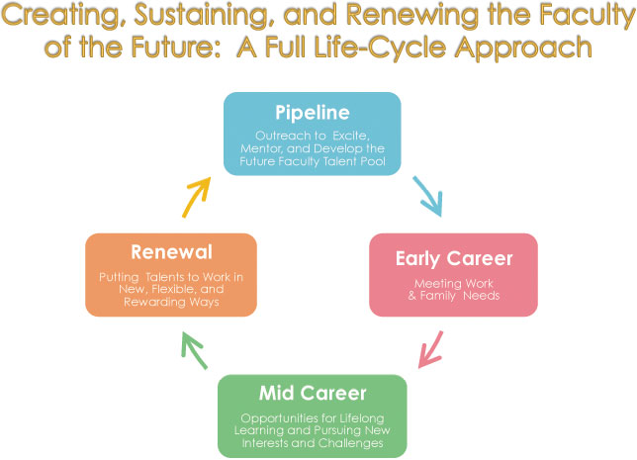](http://web.mit.edu/fnl/volume/234/kochan.html)**

**Q & A/Comments:**

**Senator Monty** referred everyone to the Chronicle of Higher Education which recently covered [*This Is How You Kill A Profession*](https://www.chronicle.com/interactives/2019-03-27-childress). They’re essentially talking about employment in Higher Education. Monty thought a lot of Senator Celly referred to as low hanging fruit actually seemed to him like high hanging fruit. He said department chairs have a role to play, but he thinks the focus needs to be at the system level, and it needs to be at the level of Academic Affairs. Some of the easiest fixes could be a more robust role for the Faculty Development Center and advocating for lecturers at the university level and with the union at the system level for improved salaries. Salaries, even with the campus-based equity program that Hagan implemented and with the victories of significant improvements in the last two contracts, Non-tenure track faculty salaries are still abysmally low when you consider that in most cases you need nothing less than an Master’s degree and a terminal degree to be eligible for a position and are getting less than $5,000 for a 3-unit course. That’s still the most important issue. When asked what can department chairs do? Monty noted that he cannot even guarantee the NTT faculty in his program that they will have an office adjacent to the full-time faculty offices because of space constraints. His ability to integrate NTT faculty into his program and develop a sense of community and involvement is beyond his control. He said he believed we need to start at the top if we’re going to achieve any of those goals. **Senator Sanford** said he appreciates what this has started in getting the ball rolling, but he doesn’t think it’s enough. He believes there needs to be recognition that if you want to help pool talent you can’t drop someone in the deep end, let them teach a class one semester, let them teach another class in the following semester and maybe give them two classes the semester after that and leave them constantly wondering if they’re going to have an income the following semester. It’s not even about having a large income, its wondering if he’ll have any income. He said he has a three-year contract, and he still wonders if he’s going to have a job. As far as evaluations, he’s asked people to come to his classes to evaluate. As far as he knows he’s never sat down with this chair and been told what he’s been doing well and what he needs to fix. Some of the things he’s been told he needs to fix are things he can’t fix because it’s related to his disabilities. He said in a corporation, he would be evaluated every year or every six months. He said Monty’s suggestion that this start at the top needs to include a set of procedures and guidelines that chairs will follow. He said there also needs to be an appeal process for NTTF and that maybe NTTF should be the ones evaluating other NTTF. He said there needs to be some way to appeal unrealistic feedback. He said he’s given up his hope for TT, but he would still like to be called a Professor.

Due to time constraints, Chair Talamante asked if Senator Naynaha would be able to delay her report until next time.

[**International Education**](https://www.csudh.edu/Assets/csudh-sites/academic-senate/docs/insidethesenate/academic-senate/presentations/International%20Education%20Report%20Salhi%20041019.pptx) **Update, Interim Senior Associate Dean Salhi**

Salhi said rather than making the case for International Education, he would go right to the impact of Internationalization given so many faculty in the room were engaged with international programs in some way.

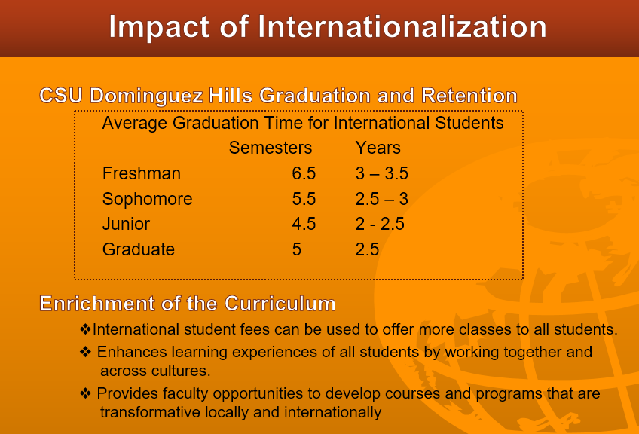

He said he asked himself what can we do with international education and how small and mid-side programs use their fees.

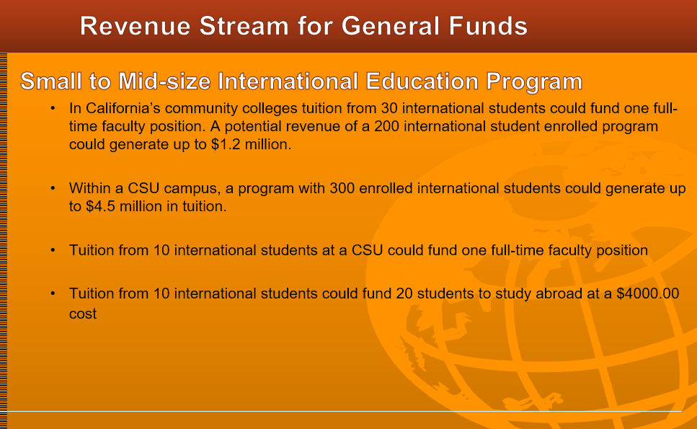

And with large international education programs:

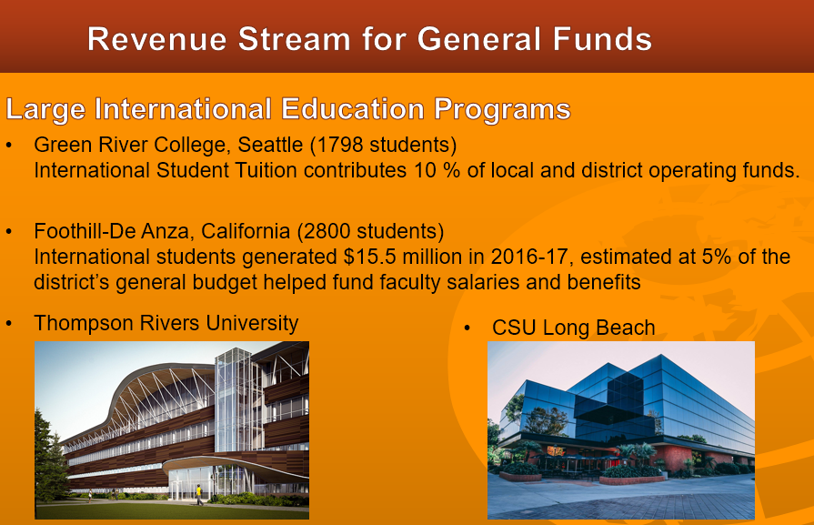

At Thompson Rivers University and CSU Long Beach some of the buildings were funded as a result of the International Education Programs.

Salhi discussed the areas where they are most in need of support to leverage Internationalization.



* Centralize all IE activities
* Strengthen Staffing
* Allocate funding for Department & Programs
* Provide Scholarships for Study Abroad
* Fund newly created Faculty Ambassador Program, Student Ambassador & IE newsletter
* Provide support for faculty stipends + release time
* Social Media Promotion and Website
* Designate funding for student services

**Q & A/Comments**

**Senator Ma** said that her experience has been where international students have not had the kind of support they need to understand processes and clear communication about deadlines. She said she’s known students who, having missed a deadline regarding housing, ended up in less than optimal housing accommodations. It is critical that they have the support they need to address the many questions that arise. **Senator Celly** said we have a Center for Extended and International Education and part of its charter is to generate monies for other stateside colleges. She said she was wondering how they feel about the tradeoff between the income generation and what is currently an area that needs to grow and will need funding before it can be profitable. **Senator Park** said she is a strong supporter for International Education. Despite all of the efforts our campus has some basis infrastructure issues, such as lacking support for the international student’s movement and taking classes. The consequence of all of that is those students do not leave here posting very good reviews of their experience. While we can’t make all of the infrastructure changes over night, she has heard that international students cannot register when registration opens for our CSUDH students, and they have to wait several weeks. If that is still the practice, there may be room for changes. **Salhi** said that an international student must have 12 units in order for them to stay in this country. The cost of their education is $15,000, $7,000 - $8,000 of which goes to student activities, but he’s not sure where that money is going. There are serious structural problems. Some of those international student get here on the weekend, but they have nowhere to go.

**Chair Talamante** asked Gary Polk who was to give the Innovative Incubator Update to introduce himself and requested that he come back to Senate, and we would make time for him at a future Academic Senate Meeting.

**Election Results for the Gender Equity Task Force, Parliamentarian Gammage**

Terry McGlynn was elected. McGlynn received Faculty Representative – 23 votes

Charles Thomas received – 10 votes

**Meeting Adjourned.**