CSUDH-Logo-Email-Signature

Academic Senate •1000 E. Victoria • Carson, CA 90747 • WH-A420 • (310) 243-3312

**Academic Senate Meeting Minutes**

**September 26, 2018/EE Rm 1213/2:30 – 5:00 PM**

Voting Members Present, Bono, Chhetri, Cutrone, Dam, Deng, Dixon, Evans, Fortner, Grasse, Gray-Shellberg, Hirohama, Johnson, Kalayjian, Kitching (proxy Phelps), Krochalk, Kulikov, Ledesma, Macias, McGlynn, Mendoza Diaz, Monty, Naynaha, Nicol, Ospina, Park, Pawar, Phan, Pong, JPrice, VPrice, Radmacher, Sanford, Silvanto, Skiffer, Tang, Taylor, Tsuno, Yi

Voting Members Not Present: Benavides Lopez, Ernst, Heinze Balcazar, Jarrett, Laurent, Still

Voting Ex-Officio Members Present: Esposito, Gammage, Joseph, Norman, Ortega, Parham, Pinto, Talamante, Thomas

Voting Ex-Officio Members Not Present: Celly

Non-Voting Ex-Officio Members Present: Costino, Davis, Franklin, Hill, LaPolt, Peyton, Spagna, Stewart, Wen

Non-Voting Ex-Officio Members Not Present: Avila, Brasley, Driscoll, Goodwin, Manriquez, McNutt, O’Donnell, Poltorak, Sayed,

Guests: T. Chin, R. Dorsey, M. Figueroa, M. Jones, N. Moy, D. Roberson Simms, L. Wilson

2018-2019 Academic Senate Executive Committee:

Laura Talamante – Chair, Kate Esposito – Vice Chair, Justin Gammage – Parliamentarian, Charles Thomas – Secretary, Enrique Ortega – EPC Chair, Katy Pinto – FPC Chair, Kirti Celly and Thomas Norman – Statewide Senators

**Recorded and Edited by SEW and the Executive Committee**

Meeting Called to Order: 2:30 PM

Approval of Agenda M/S/P

Approval of Minutes 09/12/18 M/S/P

**Senate Chair Report**

* Voter Registration Drive – There are several efforts on campus to register voters for the 2018 elections
  + ASI and the Department of History – each are sponsoring Campus Voter Registration Drives. I imagine Senator Joseph will provide some information in her update for ASI.
  + Please let your students know that through OCT 22nd – the last day to register to vote -- they can stop by the Department of History to register in La Corte Hall A-342 (3rd floor). Snacks provided!
* Gender Recognition Act
  + Chancellor White sent out a Memo to campuses yesterday regarding California’s Gender Recognition Act, signed into law October 15, 2017, which simplifies the process for individuals living in or who were born in California and who identify as transgender, nonbinary and intersex to obtain identity documents, including but not limited to birth certificates and driver’s licenses that reflect their gender. The Act provides the option to select a nonbinary marker, in addition to female or male.
  + What this means for the CSUs is that modifications to Cal State Apply, student information systems and human resources systems have been initiated and are scheduled to be on-line in October. Additional technical guidance for campuses will also be shared by Academic and Student Affairs, and Human Resources in the coming weeks.
* [CSUDH just earned a Bronze rating](https://stars.aashe.org/institutions/california-state-university-dominguez-hills-ca/report/2018-07-27/) through the Association for the Advancement of Sustainability in Higher Education (AASHE), marking the first time our campus has earned national recognition for its sustainability efforts.
  + The recognition is timely with tomorrow’s CSUDH Campus Urban Farm Open House. The Faculty Development Center is sponsoring a Living Laboratory workshop where you can learn more about our new living laboratories for sustainability: the 100% solar-powered Net Zero Innovation Center, and the Campus Urban Farm.
* The work of the NTTIF Task Force for Best Practices is also being recognized due to the leadership of co-chair Dr. Kirti Celly and Dr. Keith Boyum, and all the other member of that Task Force. Dr. Celly applied for and won the 2018 Delphi Award for Faculty Models, Programs, Policies, and Practices that Support Student Success, which will be announced at the 2019 American Association of Colleges &Universities Annual Meeting in January.
  + A quote from the award letter sums up the national implications of our campus efforts: **“You are leading higher education in transforming to support faculty off the tenure track. Your work provides an excellent and inspiring model for other campuses and we look forward to engaging with you further to promote your good work and to learn from your example.”**
  + Also, thank you to Vice Provost O’Donnell for agreeing to step in as co-chair of the NTTIF Implementation Committee as a result of Dr. Keith Boyum’s retirement.
* Talamante then asked the book store manager, Rick Dorsey and Angel Covarrubias and Librarian Naomi Moy to address any questions for how best to serve students and course pedagogy when ordering books for the spring – orders are due 10/15.

**Spring Textbook Adoptions** – Bookstore Manager, Rick Dorsey and Course Materials Manager Angel Covarrubias. **Dorsey** reminded everyone that the deadline for spring adoptions is Monday, October 15th. A flyer with additional information was made available to the Senate. Dorsey said if anyone has any questions, they’re welcome to stop by at any time. Dorsey introduced and commended the work of Course Materials Manager Covarrubias in creating the flyer. Dorsey recognized Dr. Moy from the Library as an incredible partner to have on campus. **Senator Monty** asked who made the decision that course texts were to be cataloged by author name rather than by course as it is typically done. He said he’s sure there is a rationale for this but would strongly recommend that it be returned to the common established practice of shelving course texts by text rather than alphabetically by author. Dorsey said he appreciated the input, and it was the first time he’s gotten that feedback. When asked why, **Dorsey** explained that materials are easier to find, easier to shelve, easier to process. The approach takes up a lot less space. It’s more efficient and cost effective. He said he had received positive feedback from students this fall. **Talamante** asked if Dr. Moy wished to say a few words regarding Affordable Learning Solutions. **Moy** said it continues at this campus. We’ve done a lot of work in the past and expect to expand out our programs, especially in the area of online educational resources (OER). We’re actively involved with faculty who have now gone towards these types of free online resources. However, we don’t really have a record. She said each year, she’s required to report back to the CSU, title by title, not only the library e-books but the online educational resources textbooks as well. She asked the Senate if they or their colleagues have some resources that are being used that are significant and need to be reported or you would like to have reported, to please let her know. She said they report by course title, faculty name, resource title and link to the resource, including links to the textbook. **Talamante** said with regard to professor selections and course pedagogy, she knows that issues have come up around whether or not a book should be ordered as an e-book if that’s a cheaper option. This is part of the conversation that Senate is having with the bookstore. She said if faculty have certain pedagogy needs where an online book is not the best, then they can communicate that to our materials manager. Talamante asked if Covarrubias suggest faculty following up in terms of what has been ordered for them. **Covarrubias** replied that they can send him an [email](mailto:acovarrubias@csudh.edu) and he will send them a booklist of which books are going to be used for their classes, the prices and the ISBN #’s. He added that if there’s a brand new edition, he will also provide them with that information and ask if they would like to change to the new edition or stay with the previous edition. **Moy** said currently we have SB1359, a measure which asks faculty to report courses that are zero-cost materials courses. By looking at some of the comments on the text books, it seems that many faculty may not know about this requirement. Courses which somehow say that you’re using internet resources aren’t marked with the coding in the class schedule. There are time where Moy said she’s seen DCM classes where the faculty may have three textbooks that the students actually have to pay for. **Provost Spagna** acknowledged the work of Dr. Moy and stated that he had been approached by someone at the Chancellor’s office for Moy’s outstanding work. Other campuses wonder how it is that we do the affordable learning and it’s because of your work that we’re able to.

**Parliamentarian Gammage** laid out the one election being held at the 9/26 Senate meeting, which was for the Executive Director of the Foundation search committee. Ballots were handed out. Additionally, he read aloud the uncontested candidates to be affirmed.

* Student Grade Appeals – Dale Mueller, CHHSN
* Student Grade Appeals – Thomas Philo, Library

Results of the ballot election would be announced later in the meeting.

**Results of Summer Pilot Program as a result of Executive Orders 1100/1110**

**Dr. Tim Chin, Chair of the Department of English -** Chin took the Senate through his slide presentation, first highlighting what placements looked like from 2017 and prior. He noted the placement criteria which was used before Executive Orders 1100 and 1110 was the EPT test. There was a two-course developmental sequence - ENG 88 in the summer and ENG 99 were originally semester courses run in fall and spring, but after Early Start, much of it was moved into the summer term. The result of the EPT test determined the sequence of courses needed, i.e. an EPT score of 120-140 would mean that students who took ESE 88 in the summer would take ENG 99 in the fall and in spring they would take 110 and then next fall taking ENG 111. There was also the pilot stretch program – the ENG 108 and 109 – the difference being that the 108 carried baccalaureate credit and the 109 did not. Chin then laid out what the First Year Composition Placements look like in 2018.

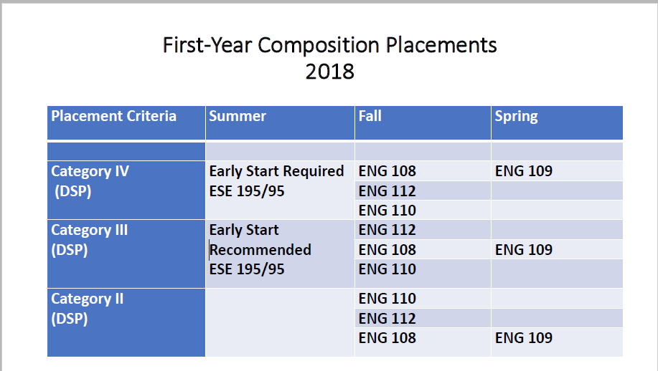

He noted that they redid the Early Start Course. Instead of two courses, ESE 88 and ESE 99, we have ESE 195/95, which is one course. It has three units, 2 units as Baccalaureate credit and 1-unit pre-BAC. The course was redone focusing on fundamental rhetorical concepts such as genre, audience, purpose, aligning the curriculum of the early start course with the revised learning outcomes in first-year composition. Chin explained that those placed into Category IV, Early Start is required; whereas, those students placed in Category III, Early Start is recommended. A course sequence in Category IV would be in the Summer, ESE 195/95, Fall ENG 108 and Spring ENG 109. Category III students, who are recommended to take Early Start in the Summer, would be placed into ENG 112, which is the supported version of Freshman Comp. That class has a Supplemental Instructional Leader (SIL), which is a student position, essentially an in-class tutor. There is an extra session on Friday that the SIL runs, so it provides students another level of support both in instruction and added seat time. The other options listed have to do with the Directed Self Placement (DSP) where students can choose the Freshmen Comp course that better suits their needs after completing an online writing self-assessment. Who enrolled? We don’t have any firm data yet, but the sense is that it was predominantly Category IV Students. There was strong outreach, and the department was behind us to get the Category III students to do Early Start English. We’re still waiting for the data to see how successful that effort was. It seems that not all Category III students took Early Start English, which on one hand is a good thing because of limited resources to serve all of those students. However, the Early Start English really gives students a significant leg up in terms of positioning them to do well in their Fall Freshman Comp class as well as in other courses where they’ll be required to do writing. On the DSP angle, it is our preferred placement method, because both the research and the preliminary anecdotal evidence strongly suggests that DSP is a much finer grain placement tool in getting students to think about and work with the kind of writing in both First Year Comp and in their college courses more broadly. We significantly scaled up the pilot that we had done for several years prior to 2018. Out of a total of 2,123 students who are enrolled in First Year Comp this fall, 1,496 completed the DSP survey, which is about 70%. The DSP survey required about a 3-4 hour commitment on the part of the student. Chin expressed gratitude for all of those who helped with the DSP instrument and getting it online, and he added it was a cross-campus effort. He continued that the bad news was that a smaller percentage of those students who completed the DSP placement mechanism, did so in time to be used during NSO to place them into their fall course. Chin said he believed this to be one of the major challenges in the next cycle to be more effective in terms of the DSP instrument. There’s quite a difference in the slide comparing Summer 2017 and Summer 2018 with the old ENG 88/99 courses and the total of the students who completed either of those courses, and then comparing those results to summer 2018 and the ESE 195 courses. We served a lot fewer students in summer 2018. Chin said they were pretty happy with the pass rate. The class caps had been reduced from 20 in 2017 to 17 in 2018, which they believe to be pretty crucial to student success. In the comparison for Fall 2017 to Fall 2018, they scaled up the stretch from 5 sections to 25 sections. They’re really looking at that class as one of the keys to serving our population of students, because of the two semesters, the SIL support, and the curriculum that’s designed to give them that extra level of support. ENG 110 increased in sections from 56 to 64, and they reduced the class caps from 23 to 20. Fall 2018 total enrollment in First Year Comp is 2123 students as compared to the 1597 last year.

**Q&A**

**Senator V. Price** asked about the training for the professors. Is it only for those who have curriculum changes or is it also for those who are teaching ENG 350, which has not had its caps reduced and it’s not had curriculum changed? **Chin** responded not yet. He said as part of the revision, they wrote a robust faculty development program to get all of the instructors, both adjunct faculty and tenure track faculty, who also teach composition, up to speed on the new curriculum and assignment sequences and all of that. There was a meeting during zero week, and they’ll be having another meeting on 9/28. There are three meetings in the fall and three in the spring. The ones during the semester come with a stipend, which is really appreciated in terms of the support from the Provost’s office. Otherwise its very difficult to impose, especially on the adjunct’s time who are working on several campuses. We have required all the composition faculty to attend the trainings because anyone who puts in a request for work should be prepared to teach any assignment that they’re qualified to teach. Usually the comp teachers are able to teach all levels. **V. Price** said there might be a little bit of a communication gap in terms of people understanding what they’re being required to do in terms of invitation and feeling like their time is being respected. **Chin** said absolutely, and he welcomes the opportunity to talk a little bit more at length with Price and anyone else who has suggestions or ideas about this issue. They’re certainly working out the kinks because they haven’t done it on this scale before.

**Chair Talamante** asked if our campus received funds from the Chancellor’s office to support our pilot programs. The **Provost** responded that we did. We received $300,000, and we will be putting in for that amount again and probably more. He said within his report he’ll share how we’re positioning that.

**Dr. Matthew Jones, Chair of the Math Department,** - Jones said he would start by prefacing it with we have students in math who are at different category placement levels. He said you can then multiply that by two because they have separate pathways for students who are in the GE population, from the STEM majors who are looking to pursue a path to Calculus. He displayed the courses offered in Summer 2018, who enrolled, and what was the pass rate. Math 102 – Category IV Students who come in with the intention of being something other than a STEM major, 484 enrolled in MAT 102 and 390 passed. In MAT 132, a supported course in Statistics, almost 90% of those students were successful. MAT 151, the first course on the pathway to Calculus for STEM majors, 66 students enrolled and 48 passed. They offered the Category II students the opportunity to take the GE Stats course, and there was a fairly high pass rate. For Category II students in STEM who wish to begin in Calculus, they were offered a 1-unit course with a placement test attached to it. Of these students, some of them qualified to be in Calculus rather than Pre-Calculus in the Fall.

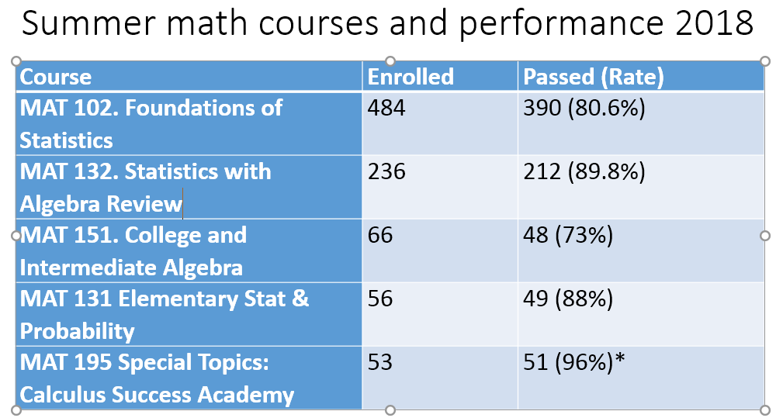

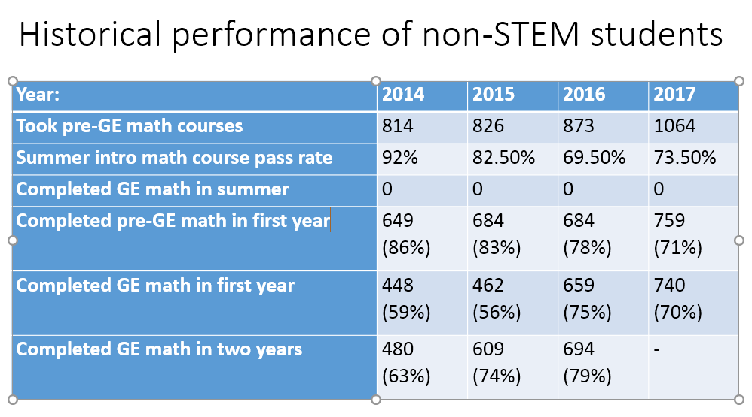

Pre-GE Math had over 1,000 students last year, and 73.5% passed that intro course. This year, we had less than 500 students and over 80% of them passed. Already we’ve gotten many of them through their GE math requirements. Jones noted that those students who took MAT132, MAT151, and MAT131, all of those students have completed their GE Math requirement, which is unprecedented. We never had students completing their GE Math requirements in the summer.

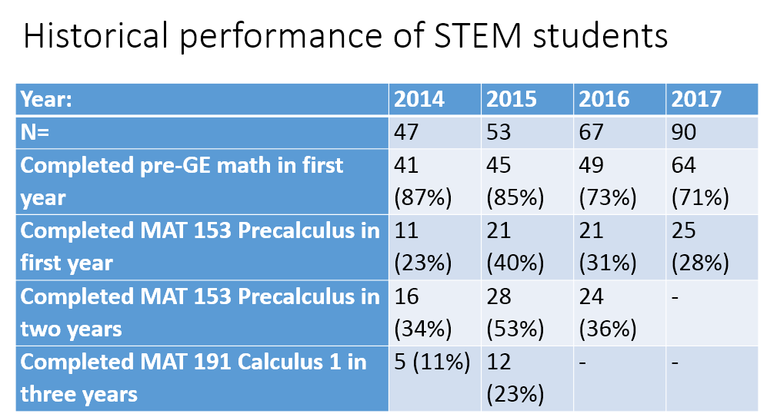

With STEM students, if they started at the pre-GE Math level, either it takes them a very long time to get to Calculus, which is ostensibly where they were headed, or they just simply changed their mind. He said he’s sure there’s some of both but does not yet have the data about how many attempt it and are unsuccessful vs. how many just never attempt it. But he knows there are both in these groups.

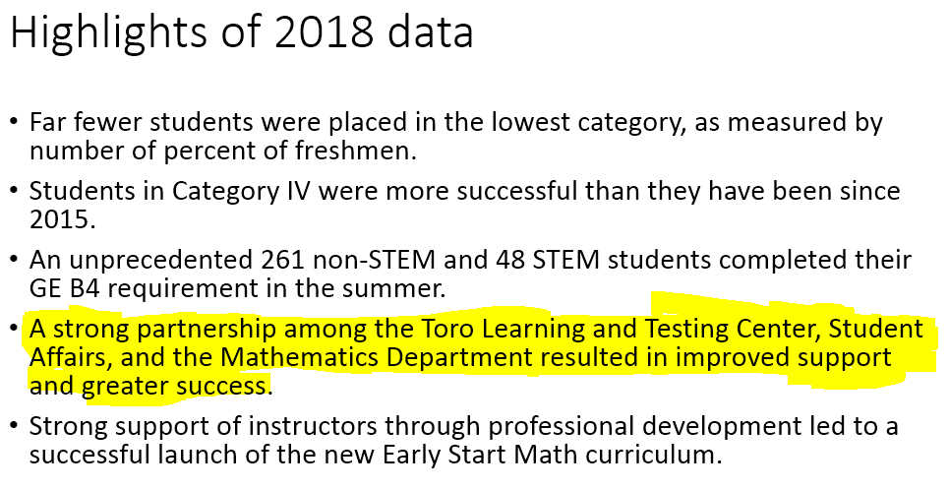

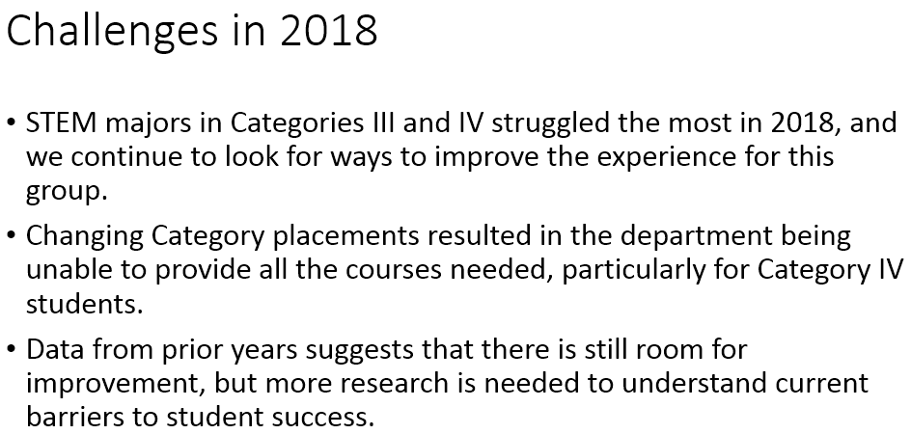

Jones noted that the issues faced changing category placements not only occurred during Early Start but also after, which wreaks a lot of havoc on their enrollment. They were not able to provide courses to all of the students that they wanted to because the numbers that needed them kept changing on a week-to-week basis.

Jones then acknowledged a list of those who had all contributed to what they were able to do during the summer.

**Q&A**

**Statewide Senator Norman** asked if he found that the Executive Order was a positive thing that helped spur change or was it a harmful thing. What has been the impact thus far? **Jones** responded it did not get in the way of what they were already doing. It also gave them the freedom to rethink a few pieces, which has been helpful. The biggest challenge was trying to prepare the STEM students who were underprepared and have a long road ahead of them. The data already says that in the past, we’ve had trouble getting them to those classes that are critical to them getting started in their major. This didn’t make it easier. It wasn’t the problem either, but it continues to be an issue. **Senator Nicol** said that Jones had stated the placement testing was changing constantly, can he say more about that? **Jones** explained, part of EO1110 was the elimination of the entry-level mathematics test, so that is no longer a piece that comes with it. The real issue now with that being gone, at our campus, an awful lot of student’s placement depends on what they did in their senior year math course. When they apply in their senior year to be Cal State students, his understanding is they type in manually what their course is in Senior year. There are variables in what the students type, which then has to be sorted and sifted through to determine what those courses are. As the grades post, if those grades are below C, that changes their placement. They could conceivably come all prepared based on an SAT score, an ACT score, an AP exam theoretically, but most of the time, that’s not who our students are. They’re coming mostly dependent on their senior year experience and what that is. When we finally get the final high school transcripts, which aren’t due until July 15th, after we’re about 3 weeks into Early Start, that makes it hard to re-place them correctly for Fall when they’ve already done their fall enrollment. **Nicol** asked if he believed that not having a placement test is a challenge. **Jones** said it’s not the placement test that’s the problem, but the lack of a firm placement is certainly a problem.

**Chin** said he would also answer the question whether or not the Executive Order was a problem. English was already on the path to certain changes anyway, and this certainly spurred those. DSP, the Stretch, and a hard look at first-year comp learning outcomes was all very good. By shortening the runway, it is a problem in some respects. The answer to the question is that it remains to be seen. Those students are in those classes now. We’ll be looking at the pass rates and other things. The English department is engaged in a robust collection of samples from those students. Those changes were good but are not going to work without the support of the whole campus. More specifically, an implementation of a multi-year, cross-curricular effort to support writing across their college career is necessary. We have some clear ideas in English, for example, the strengthening of writing intensive courses, the strengthening of writing across the curriculum efforts, getting an e-portfolio system to collect samples of student writing across their career, and crucial for us is establishing a university writing center. **Senator Gray Shellberg** said with regard to the STEM students who are not progressing at the rate that one would want, she imagined that their passion does not lie in mathematics and calculus but it does probably lie in their major. She wondered if they broadened the program by bringing in faculty or peer mentors from the major, to help them keep the motivation and the resolve to get through the math they need, to get through in order to fulfill their objectives. **Jones** responded that as it is, those courses in the summer are supported with SIL are STEM majors who are a little bit further along in the major than students in the courses. We did do some of what you described with a grant where they brought in faculty to do some STEM activities with them. He said they did not feel it had a big impact. As excited as they were to do something like that, they couldn’t see its benefits. They’re trying to research and understand what the barriers are at this point. **Gray Shellberg** said they’ve done a really good job, and it’s definitely a tough nut to crack. Maybe those of us even outside of the STEM majors could help them with the research.

Second Reading

**EXEC 18-09 Sense of the Senate Resolution in Support of a Chief Officer of Diversity, Equity & Inclusion** - Vice Chair Esposito said when they went back to revise it based on feedback they received, there were two primary areas. One was the definitions of diversity, so they added a second footnote. And the other was to strip down the resolution so that it was clear that we support the creation of an office of diversity equity and inclusion, that we support the hiring of a qualified individual, and that this individual would work with constituents across campus. A motion was made and seconded to bring it to the floor.

**Q&A**

**Senator Hirohama** asked with regard to the language in the rationale for the recommendation to hire a Chief Officer, with an office and allocated support staff, what does allocated support staff mean? Will there be a hire, Hirohama asked, or will the practice of taking existing staff and adding to their workload be followed? Or will it be opened up for internal promotion, classifying them properly, giving existing employees on the campus the ability to move into a higher level? What does allocated support staff mean? Hirohama said obviously the position has been budgeted out, but have they budgeted out the support staff for this position? **President Parham** said there are resources available to hire this position. He said we will move it to the President’s office. There are not sufficient resources at this point to put a full staff in place, but we hope to get some more. But there will be an office for this individual, and there will be staff in the President’s office able to support those initiatives, and this person will work in collaboration with all of the other administrators as well as the deans. Senator Monty said he supports the resolution. He reminded everyone that a Sense of the Senate actually means that the Senate is endorsing the recommendation of the President’s Council. We’re not passing a policy document, and the logistical issues including funding will be worked out at a later date, which is beyond the jurisdiction of the Senate. We’re here simply to support the recommendation made by the President’s Council. **Senator Nicol** asked if in the 4th resolve, should Human Resources be included. **Senator Sanford** thanked the Senate for the work that was done on the resolution in response to concerns he had raised in the previous Senate meeting. **Senator Skiffer** asked if in the 2nd footnote about Veteran’s Status, should it be included the first footnote as well. **Esposito** said they tried to be as inclusive as they could, and they tried to operate under the assumption that it is an evolving definition of diversity. If there was a request to modify it, they will. **Skiffer** said they just started a Veteran’s Center on Campus. She’s a veteran, and there are many more at Dominguez Hills. She added that veterans are facing huge discrimination in the workplace right now, so she thinks it’s important. **Chair Talamante** asked Vice President Franklin if with the position description, can it be updated to add into the evolving definition veterans? **Franklin** responded: “Absolutely.” **The question was called, and the resolution was put to a vote. The resolution passed unanimously: 41 in favor, 0 opposed, and 0 abstentions**.

**President’s Report, Thomas A. Parham**:

Parham said he began his tenure in talking with the trustees in the CO for the initial things he would like to do. He said when you see him walking around talking with various constituents, he’s really trying to do four things.

(1) See how we can align our best practices with what we say we’re going to do in the Strategic Plan. We currently operate on a Strategic Plan, which is entitled *Defining the Future of 2014- 2020*. He’s looking to assess the degree of success between what we said we were going to do to what we’re actually doing.

(2) He said he’s looking at how we’re contributing to student success. The reports from Drs. Chin and Jones are examples of that.

(3) We have lots of individuals on campus for whom this is a first-choice campus. But, Parham said, there are not enough of them. He said part of this is to figure out what we need to do to help Dominguez Hills to be more of a destination campus for students.

(4) Trying to cultivate interest and an investment in the campus as well, which is what we’ve been doing through lots of meetings.

The President then spoke about the activities he’s been engaged in.

* Board of Trustees meetings in July and September. We welcomed a new Trustee Juan Garcia. There was a big focus on international education, with several tenets of that. How are we collaborating with this institution and other folks internationally? What does that look like in terms of the composition of our students, what kind of alumni and faculty development are we engaged in, and study abroad? He said that since he’s had a chance to connect with our Provost on this topic, who shared some numbers, which are relatively small compared to what he’s seen. Parham said, “Note that we’re going to interrogate that question about how that is important to what we do here at Cal State Dominguez Hills as well.” We’ll be continuing conversation on this. They were engaged in the Trustee Awards for Outstanding Achievement. There were individuals who represented each of the 23 campuses. Our particular representative from Dominguez Hills that day was Hawk McFadzen. We had a chance to recognize here and her achievements as one of our graduate students. Another moment at the recent meeting was a particularly poignant moment were we had a chance to listen to an appeal in the public comment from not only faculty and staff from Humboldt but also from Charmaine Lawson, mother of Josiah Lawson, the Humboldt State student who had been murdered about a year and a half ago and all the challenges that he believes went along with that. Parham said we’ll continue to keep them both in prayer that they may find a resolution but also make sure we’re doing everything we need to do in terms of an environmental scan to ensure the health and safety of our students.
* There is an attempt to transition from what is a Council of 23 Presidents to a Leadership Council that is a Leadership Council of 30, the extra 7 consisting of the Vice Chancellors. This groups represents the Leadership Council. Parham said when you see that language, know that it is the same and it represents the Council of Presidents and the Vice Chancellors. We’re meeting again in October, which will take place in San Diego at the Graduation Initiative 2025. That Thursday, there will be a meeting to support the Women’s Leadership Forum. Parham noted he is excited to be there for that, especially with the celebration of the fact that more than half of the CSU Presidents are women. Parham said he would like to give kudos to Chancellor White and the Trustees for having that level of leadership. We like to tout that the CSU is a leader in public education, educating 490,000+ students, the largest public higher education system in America. To say that we can do that with executive leadership, of which the majority are women, is phenomenal.
* Gave the [Convocation Address](https://news.csudh.edu/convocation-2018/) on September 20 and laid out a vision, with possibilities and potential of what is to come.
* We were chosen as a campus to receive a [visit from Chancellor White](https://twitter.com/DominguezHills/status/1031618454921437184) on August 24th. Parham said he was able to speak with White about the opportunities and pride points of the campus as well as some of the human factors that we have to navigate, some of the challenges that we’ll continue to address and that need some very serious attention. Parham said part of the walking around he’s been doing, makes him better able to articulate to him what some of those challenges are.
* On 9/25, he participated with some of the Deans and Administrative staff in the LA Economic Development Future Forum. This is the 3rd year we have supported it as a co-sponsor. Parham said Cal State Dominguez Hills should be the place where those issues become topics of critical discourse and analysis. That Forum is not just a summary of what are the new trends going on, it’s an opportunity for us to disrupt people’s comfortable categories of intellectual apathy, so they can prepare to meet the challenges of what’s going on, but also to prepare our students in ways that allow them to be best positioned to accept opportunities within the workforce.
* Met with CFA
* Attended the Male Success Alliance, and in this meeting commemorated the 10th anniversary of the Male Success Alliance. It’s a model program that people are wishing they had.
* Met with the Board of Directors of the Dymally Institute, with a tentative mixer with the Black Faculty Staff Association.
* There was a Men’s Empowerment Summit on campus on September 8. Parham said there were probably somewhere between 2,500 and 3,000 young people on campus, in a program that was co-hosted by KJLH Radio. He said he was able to do the opening remarks and also was able to hold a workshop in the afternoon entitled The Challenges of Authentic Masculinity.
* He was invited by Long Beach President Conoley to attend the Asian Pacific Islander Initiative Committee that actually met in Long Beach. Their principle concern is the about the recruitment and retention of API students. We’re starting off outreach to the different schools to figure out how they want to collaborate with the campus to be able to continue those pipelines.
* Some scheduled and some implemented meetings with political constituents. Steve Bradford, Anthony Redon, and the Mayor of Carson
* We’re managing four searches. We would appreciate recommendations from Senate of those who can sit on these committees. VP of Administration and Finance, Senior Executive Assistant to the President, Chief Diversity Officer and the Chief of Staff.
* We are increasing efforts in transparency with our students. Parham said he’s created the Team Toro Lunches that meet the first Monday of every month. This is an opportunity to bring the entire cabinet, along with the Dean of Undergraduate Education, Dean of Graduate Education, the Academic Senate Chair, the Director of Athletics, and the Chief of Police—all of senior leadership meeting with the student executives and listening to what’s on their mind. With the group talking to them about those issues and helping to resolve whatever those issues are. We initiated the topics at the first meeting. ASI will prepare the agendas going forward and send them forward to us a week in advance.
* Looking forward to new faculty hires. He said he is keeping his fingers crossed for maximum success. We’re looking at the budget to see what we can carve out. President Hagan had promised 20 hires and a year of FTEs, which is large. Parham said the Provost stretched a bit and then we had to bring those down, but it looks like we’ll be able to get to 24. Those have already been distributed across different lines. The challenge is not simply to allocate the dollars, it’s to be successful in the searches. We would like 100% success on those particular searches. That’s our goal. Part of making this a destination campus is not simply about attracting students, its about attracting and continuing to attract talent to supplement what it is that we already have.
* We’ve been hosting and engaging with the philanthropic and corporate community. Parham said he’s been attending as many breakfasts, lunches and dinners, public events and private events as he can go to see how people want to get involved.

**Q&A**

**Senator McGlynn** said there’s extraordinary anxiety that we haven’t placed our ads for hiring this year. Agreed that’s its imperative that we have successful searches and that we get strong candidates. But every day that goes by reduces the probability that our searches will be successful. To the point that even if we advertise now, it’s almost too late. How long will it be before we can place our ads? **Provost Spagna** requested that Interim AVP Hill address the question. **AVP Hill** said that we just made some tweaks to the position descriptions just before he came to the Senate meeting with input from Senate Exec. It should be the final round. The templates should be available within a day or so. **The Provost** asked that the templates be shared and then out within 24 hours, so that they’re completed by the end of business on Thursday. **Senator Monty** said the Senate passed a resolution two years ago that requires that decisions be made in the spring semester so that we would have already known by the time of commencement last year, which programs we would be searching so that we can get the approval for our position description and post our ads in August or September. The Provost did accept that they fell behind schedule this year for a variety of different reasons, and he pledged that this year the decisions will be made and communicated in a timely fashion. He said he wished to reiterate that the problem was not the templates. The problem is that the decisions were not made and communicated until too late. **Spagna** said he reported at the last meeting that the final memo was approved with the 24 slots mid-August in terms of budget. He said he gave to Executive Committee in the last meeting a modified timeline that pushes up tentative approval to April of 2019. He said his plan is that the departments will have in April tentative lines to go ahead, do the template, prepare the searches. Then there will be another process whereby you’ll get these tentative lines, you’ll all be set up, but if we’re not funded for them, you’ll have done the work where it doesn’t go forward, but at least we won’t be running against the clock. That’s the thing to hold us accountable for going forward. **Chair Talamante** said we have had a discussion about having a meeting with Faculty Affairs to see what we can do to streamline once the go ahead is given, so that the ads can go out in a timelier fashion to meet our goals of rich pools of candidates and diversity and inclusion. **Hirohama** said she is hoping that somehow senior management will somehow start looking at filling open staff positions in a more timely manner. As people leave or as people retire, a lot of times those positions are held open. Job duties get dispersed. It seems that people wait until the wheels start falling off the bus. One example she said was payroll. They had a manager and about four or five people in there. It got down to two staff people. When things started to get really bad is when they decided to start hiring. One person was going to leave, and it was going to be only one staff person. She said it’s not the only department that got reduced down to one or two people that used to have four or five. She said there’s discussion about needing to reorganize, but in the meantime, a lot of things need to get done. She said she’s heard where some people want to present data but can’t because only one person works in that office. **Monty** said the he wished to echo Senator Hirohama’s concerns. Staff shortages are a chronic problem on this campus. Part of it is that there’s a great deal of turnover and there’s a lot of turnover because he often gets the impression that it is not a nice place to work as a staff person. Compensation is a serious issue and for many, training and professional development opportunities are difficult to come by. Problems of overwork is chronic because of the persistent shortages. Monty said with a new President on campus, it’s an excellent opportunity to bring this to the floor and keep it in the forefront of our minds and do something about it. **President Parham** responded, “Please know that your President has heard your plea.” He said he’s not responsible for what occurred before he got there, but he is listening intently and will move forward. He asked that we recognize that in all that we do there are priorities that we give both to the hiring of both faculty and staff. We have to able to have the appropriate human infrastructure in place to be able to manage the affairs of the university. If it’s within our control to speed up in a timely fashion searches and other things to try to fill positions, we will certainly do that. Parham asked that we also keep in mind that we are a resource-constrained campus. As we have decisions to make at the administrative level, whether to fill those positions or shift those dollars over to someplace else who happened to need it, these are the challenges we have to explore. He thanked everyone for their continued patience. He said he arrived on campus in July. For him to have met with Cabinet, look at budgets, examine priorities and meet with Academic Senate Exec committee and then make some decisions and then signed off in August, that was lightning fast. He said he will work as hard and as fast as he can, but we will do the best that we can with what we have.

**Provost Report, Michael E. Spagna:**

* We have a visit from West Ed, October 22 and 23rd. They’re coming out to see the exemplary implementation of Executive Order 1110. They’re coming out with a team to look at all the things you heard Chin and Jones report on today about the choices we made, the courses designed, what the outcomes are. We continue to push for research support and funding support in baseline to keep the activities going on for Executive Order 1110. We look forward to that as a result of the study from West Ed.
* Strategic Enrollment Management Planning – There is an upcoming presentation that will take place in front of the Senate to give you an update of where we’re going. One element we’re looking at is “Student Shape”, this will be an issue to look at in terms of what have we done over the last five years and what do we want to do over the next five years.
* Cyber Security Skills Shortage Report – Spagna said this is a poignant example of where Dominguez Hills is at its best. In Computer Science, there was sensitivity to workforce demand. 1.8 million jobs are going to be unfilled in cyber security in 2022. There are 35,000 job openings in California. As of April 2017, the starting salary is $75,000 - $100,000. 75% of organizations report understaffed security teams. In our Cyber Security Masters, working with Extended Education, we have a very aggressive program, which is recruiting students into this job force. At the Freshmen Convocation, there was a wonderful speech by Erica Tinsley who said she wondered why it was she was taking phone calls for seven years about trip planning. She wondered why it was that these people were able to take exotic trips and realized all of them had college educations. Spagna noted that it was one of our faculty who brought this student in, and she now is the Chief Security Officer at Raytheon. That’s the success story that matches the three areas of workforce need, our excellent programs, and then what we do to manage that.

**ASI Report, Daylin Joseph, Vice President, Academic Affairs:**

* This past Tuesday was Voter Registration Day; we had a drive where we registered over 100 students. We will be doing another registration drive. Afterwards we will be educating students on the Propositions that are being voted on so that they can make informed decisions.
* Limited Seats in Classrooms has been a hot topic for why students are stopping by ASI. Many students have said they’ve had to sit on the floors or make sure they come in 10 minutes early to make sure they get a seat. ASI has been working with students to make sure they’re comfortable in their classrooms.
* ASI has received a presentation from our Sustainability Department about efforts to make sure we are a green campus and what we’re doing to move forward.

**Q&A**

**Senator Krochalk** asked did Joseph mean that there are insufficient seats to fill that have been designated for the cap for that classroom or that there is space, which students think you can always fill up and bringing chairs from other classrooms? **Joseph** responded that there are seats designated in those classrooms, but there are just too many students enrolled into that classroom, so there are not enough seats. **Krochalk** further inquired, “To fill the capacity of the room as designated by the university and fire safety?” **Joseph** responded, “Yes.” **Senator Radmacher** noted that the room capacity was listed as 38 students, and then they had 38 students but not enough chairs. At the beginning of the semester people were moving chairs back and forth between classrooms, and she said she did not believe that the chairs were reallocated to their classrooms appropriately.

**CFA Report, Daniel Cutrone**

Cutrone said he would like to make it clear that our CFA welcomes Dr. Parham and that our mission here is not to pass judgement. He said they extend an open hand and are enthusiastically looking forward to sharing our vision and to continue the close relationship that currently exists with our administration. He continued that they wish Dr. Parham to know that our university took a very active role as we sought a new president. Our Senate took an extraordinarily strong stance to make sure that we had a voice in the process. Our presidential selection task force was composed of members from across our campus that came together as a unified voice. It approached this mission believing that we could shape the future of our university. There was an over whelming agreement that the correct choice was made.

Behind the Scenes our CFA continues to remain active and should be considered the “live wire” between our members and our university’s administration.

Cutrone highlighted Past Events

* Thursday, September 13, 2018, CFA Chapter hosted a Welcome Back Lunch. It was a well-attended successful event, which allowed our CFA members the opportunity to meet our current steering committee, discuss our goals, and most importantly renew friendships and welcome our new members.
* Thursday September 20, 2018, CFA held the Lecturers & New Faculty Orientation in the Faculty Development Center, which was presided over by Dr. Vivian Price and Jackie Teepen our CFA Representative. Both Dr. Price and Jackie Teepen shared their many years of service, answered questions, and gave advice.
* The Steering Committee and Labor Management Team met with Dr. Parham, the Provost, and Dr. Hill to personally welcome him and present our CFA Labor Management goals. Foremost was the desire to continue and be afforded a meeting time on a regular basis in the interest of keeping the stable, accountable, as well as accessible and transparent relationship that past Dominguez Hills administrations have provided. At present, there is concern with some basic issues, such as safety, the functioning of student services, and the sometime confusing communication between faculty, staff, and administrators. It was noted that there are many outstanding faculty rights issues that need to be addressed. Our aim is to prevent “DISAGREEMENTS” from becoming “GRIEVENCES.” If both sides are working together collaboratively “our” energy together can be used to the benefit of all. We also expressed concern about our faculty being majority part time and that Dominguez Hills has the lowest percentage of tenure-track professors in our California State University System. When looking for new hires, we would like to see new hires begin with those dedicated faculty who have currently been working here. It was noted that there are faculty members with 10 to 20 years of serve that have never been offered a full-time position. We want to see that lecturers have professional development funds for research and conferences, as stated in our current contract, so they can keep current in their fields Most importantly, we strongly strive to continue with a collaborative stance in order achieve a “cohesive” relationship. Cutrone noted that our CFA “represents a faculty that is dedicated to its students and our university’s mission to address inequality and combat discrimination against African American and marginalized communities.”

Cutrone noted that there was a CFA Conference coming up in October.

**Senate First Reading Item**

**Exec 18-10 Resolution Calling for Timely Notice and Scheduling of MPP Campus Visits, Vice Chair Esposito** Esposito asked for a motion to bring the resolution to the floor, which was seconded. She noted that there was a typo in the resolution in the 5th resolve where it should read campus stakeholders rather than students. She said it is very similar to the resolution that had been passed two years prior regarding Timely Notice for scheduling potential Provost visits. The resolution talks about requesting that open forums be held during the academic semester; it asks for advance notice for when we anticipate they’ll be so we can plan long term; for the times when we are given some expected dates, that we’re given at least a week’s notice for the greatest participation for all of the campus stakeholders. **Senator Ospina** asked why the Library Dean wasn’t listed on the distribution search. Additionally, the Library wanted to raise the concern that a search they worked on recently, due to a number of obstacles, wasn’t able to get started until late June. As 12-month faculty, they work very closely with their Associate Dean, putting a search off until the following semester could be detrimental to a search. She said she understands the reason for this resolution and wouldn’t necessarily vote against it, but they did want to raise that concern. **Esposito** said they would bring it back at the next Senate meeting.

**Tenets of System Level Shared Governance in the CSU, Statewide Senator, Thomas Norman**

Norman reviewed the three documents that were part of the Senate package. He said we’re looking at the Statewide Senate to vote on Agenda Item 10.1. Should we adopt these Tenets as more formal policy in collaborating between the Statewide and the Chancellor’s office going forward? To understand this though, Norman suggested that they first bring their attention to the actual Tenets and what they say. He said the Tenets give reference to what the role of faculty should be, which is a role of primacy, meaning the most important voice when it comes to certain matters. He continued to lead the Senate through areas of the Tenets document. He said the question you want to ask yourself and provide feedback on is, is this the right direction for future Statewide Senates to go? Should we only pursue a collegial relationship with our Executives, or should we perhaps do what the other document that was included in the package, which is a resolution that states we shouldn’t be rushed to vote on this document with very little notice to bind future senates to anything in the document and we shouldn’t be voting on a document that was presented as a “take it or leave it” document? Norman said we were not given the ability to edit the tenets at all. If there is anything in the tenets you don’t like, that’s important to note. Norman highlighted an example given to him by a fellow Senator from CSU Fullerton. He said it’s important for Senators to review the materials. **Senator Nicol** said since she writes about the Trustees in her research, she’s a little concerned about the Tenets, 3rd or 4th page, 2nd paragraph where they’re saying that the “faculty voice is given the greatest weight, although the authority of the final decision resides with the office of the Chancellor.” She asked how do we know how the faculty weight is given? And if the faculty do all of the work to bring a new major online, and the Trustees and the Chancellor decide that they don’t like it for whatever reason, which is what happened with Black Studies when it was being created, how do we know that the faculty is not going to be disregarded simply because one administrator decides they don’t like something? **Senator Monty** said if you’re unable to do so today, I would hope that you could provide a little more background for new Senators about the 1985 Board of Trustees Statement on Shared Governance and how Shared Governance is defined in HEERA. This document and the resolution that was passed by the ASCSU in May of last year commending the committee for its work, is a whitewash of Chancellor’s White’s repeated violations of shared governance. Monty said White in fact refuses to use the phrase. Monty said that White says he doesn’t believe in shared governance, instead he believes in shared leadership. He’s been acting in bad faith as long as he’s been Chancellor of the CSU. Monty continued that things came to a head last year because of the top down way in which Executive Orders 1100 and 1110 were passed with very little consultation, with very little regard for the valid concerns raised by faculty in terms of unintended or unanticipated side effects and consequences of these Executive Orders as well as the aggressive timeline for implementation and their unwillingness to grant any kind of exceptions. Monty said that as far as shared governance goes, there is a crisis and White is simply following in the footsteps of his predecessor. Monty said what would be more helpful than the tenets, would be to reaffirm and demand that the Chancellor reaffirm a commitment to shared governance as it was defined in 1985 and in HEERA. That would be straightforward enough. If that can’t be done, Monty said he would recommend that we compose a resolution instructing our Senators to vote against the Tenets unless they’re substantially modified in a number of ways. Monty added that he would include that we urge the ASCSU to also reject the Tenets unless they are modified. Monty continued, that in addition to the loophole identified by Senator Nichols, he would also point to the timeline. 75 days is not a lot, but it’s more than we’ve been given by the Chancellor’s office at some points in the past. He said how often our Academic Senate meet, mobilizing faculty across 23 campuses to give deliberation to serious issues, like general education and how to manage Math and English composition requirements. Monty expressed that those cannot be done in 75 days, they should be given an entire academic year at a minimum. Lastly what he thinks is most problematic, is the part that basically states that the Chancellor reserves the right to act however he sees fit and whenever he sees it necessary, he’ll throw the tenets out the window. Unless that part is completely stricken, then there’s no way we should accept the Tenets because they’re not a roadmap for advocating shared governance. **Talamante** pointed out that there’s nothing in the document that really addresses communication with the campus senates, it really only addresses the relationship with Statewide. She said with this in place, she does not see that we would have any better opportunity to respond than previously. **Statewide Senator Thomas** asked the Senate if they would like to poll the Senate to see how many are in favor of creating a resolution as described by Senator Monty. **Chair Talamante** asked if all those in favor of having the ASCSUDH bring forward a resolution to Statewide to say AYE. Those opposed, NAY. **The Senate body agreed unanimously.**

**Senate Retreat Roundtable Report Back**

Table 3 – Chairs Elections/Duties/Reassigned Time/Compensation, Facilitators Pinto and Radmacher

**Faculty Policy Committee Chair Pinto** said that she and Senator Radmacher worked on the responses that they had received from the five questions that were up for consideration at their roundtable at the Senate Retreat. She said that they’ve been discussing in the Faculty Policy Committee the five themes and take them as a suggestion of how to move forward. One of the things they’ve definitely been discussing is the Chair Duties. She said one of the goals they have this year is to bring a resolution to the Senate floor to update what we currently have around chair duties. We do have a policy on the books, but one of the big things that came up from the retreat, that while there may be a document in place, it does not address compensation, nor does it address the changing landscape of what chairs do. She said Faculty Policy Committee has been looking at other policies that exist and reviewing policies that exist on other campuses who have tried to deal with compensation issues in their academic policy. Additionally, opening the lines of communication to invite any chair who would like to come to the Faculty Policy Committee meeting, Pinto said they meet the first and the third Mondays of the month. The next meeting is Monday, October 1st. Additionally, they’re working with the Chairs Council to solicit all of the different points of view into what a possible resolution could look like. Lastly, what has come up has been some issues around sabbaticals. In the suggestions of what we could take on, there’s a policy around sabbaticals but there are questions about the procedures around sabbaticals and how sabbaticals are scored. The current policy might date back to 2005. Pinto is in consultation with Interim VP Hill on the matter. She concluded that what you may see in the content of the notes from their Senate roundtable discussion is that there is a sense of some urgency from both the Provost office and from the faculty that we would like to work on the chair duties, chair compensation, chair definitions and bring up our policies to a more clear, modern, transparent state. **Senator Radmacher** added that we really need to do it for program coordinators as well. There seems to be some uncertainty around the role and the duties of a program coordinator. She said when she was in the role of program coordinator, she basically was doing the duties of a department chair. She said she believed there needs to be clear distinctions between the two and what those duties are. There may be some program coordinators out there who should be elevated to chairs and there should be a clear distinction between them. **Pinto** added that one of the Faculty Policy Committee members is from the Library and that in some of the existing language, the group that we don’t seem to have language around are the librarians and the coaches and other Unit 3 faculty. This is also something that we’re looking into. **Secretary Thomas** said in addition to making sure we update the duties is also to make sure that it’s clear as to whose responsible to make sure those duties are carried out. He said it’s important that we’re thinking along those lines as well. We need to make a commitment to making sure that policy is enforced. **Monty** said if we are updating the document, he would also like to see included is the duties of Deans and Academic Affairs more generally to chairs and program coordinators. We need their support to do our jobs. The existing document has language about the responsibility of chairs but nothing about the obligation and responsibility to those who support chairs and the accountability for that. **Senator Krochalk** commented that there was a time when MPP’s served as essentially chairs of departments and departments or units would come under an MPPs office. If that is still the case, this is an extremely important issue that should be addressed. **Thomas** said it still is an issue, such as in Applied Studies where there is an MPP currently serving as a Chair. He commented that under past Provost Junn, three faculty were getting stipends, but it’s not the right structure.

**Table 5 – Establishing Transparency in Academic Affairs Budget Process: Creation of an Academic Affairs Budget Committee & College Budget Committees, Facilitators Gammage and Norman**

**Gammage** said they talked about different ways they can be transparent, understanding that this is an ongoing conversation. One of the points that came up was not only to being able to track the money, such as in Opengov, but also to be part of the decision making as it relates to how the budget is distributed across campus. He said one of the things they talked about was to engage the faculty knowledge base as it relates to how budgets are distributed across campus, more specifically at the college level. One of the things they wanted to engage faculty in has to do with establishing a budget committee within Academic Affairs and what that might look like and faculty would be a part of that committee as well. Gammage said one of the things they did conclude during their discussions was that faculty didn’t know a lot about transparency with college budgets, which he said they found troubling. That there wasn’t a standardized budget process set in place in which faculty from different college could be able to gauge how colleges make decisions in regard to their budget and more importantly having faculty involved in that process. Gammage handed the mic to Senator Norman. **Norman** added that there also seemed to be not much knowledge about how departments had budgets or if their departments had a budget. He mentioned that CAH seemed to be aware of department budgets, but the other 80% did not seem to be aware that there were such budgets. **Krochalk** said she’s heard some discussions about shared governance lately and the dichotomy that faculty are in charge of curriculum and that administrators are in charge of operations. When we look at it that way it’s a bit simplistic because the two are very highly related. Faculty can work very hard on all these different issues, but if the resources aren’t allocated in that direction then it’s not going to go anywhere. She asked: “How do we bring these two together in a collaborative, collegial way so that we don’t see the dichotomy. That there is this middle ground where we can get to common agreement that these are important curricula issues and yes this is something that the budget supports.” She concluded by saying that the dichotomy is really naïve and artificial from her perspective. **Senator Phan** said for the past five years he’s heard that his college department’s budget they’ve been working from allocations that were made a long time ago. He continued that he hears every year when the question comes up that administration is working on a budget. He asked if that were true? **Provost Spagna** said he too heard that when he got here, and that the scenario was what did you have last year? Well that’s what you’re getting this year. He said they’ve been moving among the Deans and the Associate Deans and the AAC. He’s asked the Deans to present what they’ve shared related to the budgets at the level of college and departments. He said currently it’s varied. Some are doing some reports, some aren’t. He said they’ve been working, particularly at University Budget Committee, to provide a university overview of the budget, and an Academic Affairs overview of the budget broken out by college. Vice Provost O’Donnell and he are working on a template that would take that presentation to go down the colleges so that that would be provided to departments to see how much each college gets and where is it apportioned. There would be another angle, which would be at the department level, what are you getting, what’s O&E and what are the colors of money? He said they have the willingness of the Deans to participate fully in it. Over the next two weeks they have an upcoming University Budget Committee meeting, an Academic Affairs Committee meeting, and he will be presenting it to the Senate Executive Committee to be able to see the template. He would expect that by November he’ll be able to give a larger presentation to the entire Senate about what this will look like. He said at the end of the day what needs to drive decision making related to budget is the degrees of freedom within a department about professional development, equipment and all the rest. One of the things that has hurt us all historically is there has been no projections related to budget to try to make us whole. At the end of the year it may look like some of the colleges have been operating in the deficit; they’re not since they were never given the resources they needed to actually provide the instruction they’ve been providing. He said they’ve been working at normalizing that budget, increasing it, pretty significantly in some areas so that now we’re working with what’s really necessary to fund this. **Gammage** asked if in addition to determining departmental budgets, will there also be a mechanism or some type of formula that’s standardized across the university to show how each department budget is determined? **Spagna** said that is going to have to be a joint conversation. What are the thresholds that we want to have that all departments have access to, and what is it about individuality that all departments want in terms of access or how they get across it? It’s an unanswered question now, but a good direction to go into. What is important at the end of the day, is that departments know what the different colors of money there are. Spagna said when he says colors of money, he said there are certain monies for O&E, there are certain monies for lottery, and there are different conditions for them, state vs. outside money. Eventually, Spagna said he would advocate that departments have subcommittees or subgroups that are budget related that can give reports to the entire department. He said you would want to get to that level, where there are budget committees at the department level, the college level, and at Academic Affairs. That is an allowance to have open conversations about what do we do with it. **Phan** had a follow-up question and asked at what level do faculty and/or department chairs have input? **Spagna** said you’re going to get the budget picture and then the input is really going to be along the lines of decision making. If this is how much O&E money you have, or if this is how much money you have in the department from year to year. Let’s say a department is very successful in grant activity and a certain amount of money is coming back. Then, the department budget committee has a degree of freedom to decide what they do with the money collaboratively.

**Election Results**

Senate Chair Talamante passed the mic to Parliamentarian Gammage to announce the results of the paper ballot election of the Search Committee for the Executive Director for the Foundation. **Gammage** reported that the two that were elected were Maria Avila from CHHSN and Bing Xu from CBAPP.

Meeting Adjourned