Academic Senate 1000 E. Victoria Carson, CA 90747 WH-A420 (310) 243-3312
Academic Senate Meeting Minutes
September 27, 2017
LSU 2:30 – 5:00 PM
Voting Members Present: Abdourazakou, Benavides Lopez, Bono, Cutrone, Dam, Deng, Evans, Ferris, Furtado, Gaines, Grasse, Gray-Shellberg, Heinze Balcazar, Jarrett, Kaplan, Krochalk, Lacanlale, Laurent, Ledesma, Luckett, Ma, Macias, Mapson, McGlynn, Monty, Naynaha, Needham, Palladini (proxy for Kulikov), Pawar, Peyton, Phan, Pong, Price, Quintero, Radmacher, Skiffer, Still, Tang, Tsuno, Yi
Voting Members Not Present: Cid, Ernst, Johnson, Kalayjian, Ladd, Nicol
Voting Ex-Officio Members Present: Avila, Celly, Esposito, Gammage, Hagan, Iheke, Norman, Ortega, Talamante
Voting Ex-Officio Members Not Present:
Non-Voting Ex-Officio Members Present: Davis, Goodwin, Hill, Huizinga, LaPolt, Manriquez, O’Donnell, Salhi, Spagna, Stewart, Wen
Non-Voting Ex-Officio Members Not Present: Avila, Brasley, Carrier, Driscoll, Franklin, McNutt, Poltorak, Sayed
Guests: K. Boyum, T. Caron, R. Hay, V. Hernandez, D. Miller, M. Ortiz, M. Vazquez
2017-2018 Academic Senate Executive Committee:
Laura Talamante – Chair, Kirti Celly – Vice Chair, Justin Gammage – Parliamentarian, Enrique Ortega – EPC Chair, Maria Avila – FPC Chair, Kate Esposito – Statewide Senator, Thomas Norman – Statewide Senator

Recorded and Edited by SEW and the Executive Committee
Meeting Called to Order: 2:30 PM
Agenda M/S/P
Minutes revised, three senators names were inadvertently omitted in printed minutes. Phan, Pong, and Quintero were present at the 9/13 Senate meeting, their names were included back in to the revised minutes. M/S/P

Senate Chair Report
- Senate reception after meeting beginning at 6 p.m. Parking, in lot #15 is free. Chair Talamante looks forward to seeing everyone tonight.
- Talamante noted that after the big news of the President retiring, an additional agenda item is that we’ll be looking for tenured faculty to serve on the search committee for the new President. Talamante noted the President’s comments on all the wonderful things that have been in the works and are going to take off this year, which Hagan will continue to help to bring to fruition. She noted that according to the letter she received from the Chancellor’s office, they’ll be looking for two tenured faculty to serve on the committee, along with herself. She said we’ll be taking nominations up until Monday, October 9th and voting on it at the October 11th Senate meeting.
- Visit last week from Vice Chancellor of Human Resources Melissa Bard. Talamante noted that Bard was here the entire day visiting with many different constituents, including Senate Exec, cabinet and students. Talamante had asked Bard if she wouldn’t mind sending a follow-up note on what she learned after visiting with everyone. Talamante read aloud the email sent by Bard. “I enjoyed my visit and I very much appreciate members of the Academic Senate taking the time to meet with me to better understand the challenges and opportunities your campus is experiencing. Although the CSU is one university, each campus is unique and my visits are serving to 1) educate me on the campus culture, and the challenges and opportunities at each university, and 2) allow me to build relationships with members of the campus community. While at Dominguez Hills I learned that the university has facility challenges and is in need of new academic buildings. I also learned that the students love their university, but feel like Dominguez Hills is the “stepchild” of the system, and find it a struggle to get the services they need to be successful. These are things I have heard from others, but seeing them firsthand allows me to be a better advocate to the Board, Legislators and others in my executive role. From a human resources perspective, it helps me to better understand the struggles our faculty and staff are facing, and offers me the opportunity to consider where HR can help and be a better resource to campus.” Talamante said they were encouraged by the personal visit, the interest she took in the campus and the questions she asked about us about our experiences here, what makes us passionate, what keeps us here, and what are the challenges we face.
- Retreat Feedback
  - Free speech, a number of questions that emerged as a result of that conversation as well as suggestions for ways to address this.
    - There is a handbook of free speech issued from the CSU, our question is, is this a required guideline for all CSUs or does it function as a guide or template.
    - We had requests coming out last year; from ASI and from Senate Retreat for designated free speech space such as where is free speech allowed. The east walkway is not a space student’s chose. Students felt pushed there, but students are usually denied this area for protest
    - Question about freedom of speech platform near the library, but has not been used for a number of years and other campuses as Long Beach has designated spaces.
    - Questions regarding campus policy – is there a university policy for permits to practice free speech? Does it allow the university community to prepare and to address and allow students to respond to free speech issues on campus? What is the policy regarding inviting speakers.
    - Creating a freedom of speech educational program. Senate and ASI request to have training for how to have difficult facilitative discussions regarding free speech in classrooms and public speaking forums
    - We would like to see a collaboration between Academic and Student Affairs with elements to include asking for what students see as for ideas for free speech and know your rights.
    - Student Affairs suggestion – ASI and Student Clubs and Orgs have a required leadership skills and training at the beginning of the academic year
    - University 301 Leadership course could be a better place to embed that kind of training for students
    - Question on whether or not there was an ASI policy on what is considered free speech
- We received request from Deans regarding online hybrid education. One of the questions was with regard to online proctoring support. There was a demonstration by a vendor to the folks at CHHSN, who had a demo for a potential pilot that was not adopted. Reza continues to look for what might be a better answer to our needs. Deans and faculty were invited to attend, including the EPC Chair Enrique Ortega. There will be a two-month free online pilot for interested faculty in spring 2018, further details to come.
- Talamante requested that Dean Salhi speak to the teleconference faculty are invited to regarding EO1100 and EO1110. Interim Undergraduate Dean Salhi said the current venue for the teleconference is in the Library on the 5th floor in the conference room of CAH. 20 people have registered thus far. Deadline to respond is today at 5:00. The webcast will be from 2 – 4. It’s an opportunity for us as a campus to ask questions about these EO.

Q&A/Comments:
Senator Monty asked if anyone from the Executive Committee would be attending. Talamante said she would be. Senator Heinze-Balcazar asked if we would get an opportunity to hear about the ideas from other committee tables that were generated at the retreat. Such as EPC, FPC, Budget Committee and Tenure Track vs. Part-time and any of the other discussions that came out of that day. Talamante said we will be reporting back incrementally, and she will look to see what we have not yet reported on. She said there would also be a document on the Senate webpage summarizing the discussions from the various committee tables. Heinze-Balcazar said, she understands the GE committee had some ideas generated out of their discussions and would be very interested in hearing about it. Talamante said she’ll make sure of it, and we’ll have that on the next agenda.

Parliamentarian Report
Senate Parliamentarian Justin Gammage read aloud the various committee appointments so that the Senate could affirm these faculty.

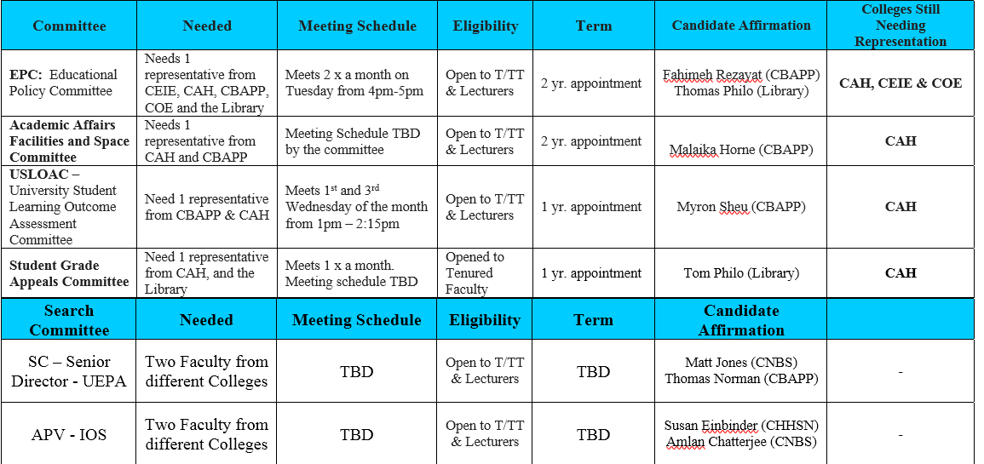

Gammage noted that there are still committees that need representation. Refer to the right hand column and if you know of anyone who might be interested, please ask him or her to submit their name or ask them if you can nominate them for consideration.

President Hagan’s Report
- Great reception regarding the fabrication laboratories. Hagan said the Campus Labs vehicle you saw is one of four and will really help in the community in terms of bringing STEM education to many middle elementary school children. There were people at the reception whom we were courting to provide additional funds of support to our STEM programs in general. We’re going to be doing some fundraisers with them and some other corporations. Hagan said the Fab Lab program is a great program and it was the first time he had actually seen it open, and he said it was very impressive with the work that they do and the way that they engage students.
- Ground Breaking at 6 pm for the new science building tomorrow at 6 pm.
- The University Village Plan has been approved by the Board of Trustees, which is also part of our overall land development plan. We can now go out and start to engage developers. It is a very solid plan in terms of the market analysis that has gone in to it. Hagan said he’s very excited about what it will do for faculty/staff housing, research opportunities and includes a park. It’s primarily about generating revenue for the university and we believe it will do quite a bit for us.
- Retirement – President Hagan spoke about responses he’s gotten from different people regarding his announced retirement. Hagan said he really enjoys this place and the kind of place that he wakes up and enjoys coming to. He said he didn’t want to be the person who stays too long. He personally feels like it is the right time to go. We’ve accomplished a lot and have a solid year to do even more and he plans to make himself available to volunteer and be part of the university afterwards. He said the university is a part of him. He enjoys the Male Success Alliance program and the guardian scholarship program, and there’s many opportunities to volunteer and stay involved.
- Hagan noted that the search for the new President will be underway and the first open forum is on October 31st. He said the search committees really want the feedback from the campus. The kinds of skillset that people want in presidents, like the vision side, strong academic side, the communication side, the “work under the hood”, the department side and you’ll find many people with all those skill sets. However, you want someone who “fits” the campus. He said this campus has a unique and wonderful culture, and you want someone who when they come in is going to want to work with you to continue building that. There will be three faculty members from the campus, a staff person, elected by the staff, a philanthropic member, and a student, someone from the alumni board. Hagan said based on his experience serving on the search committee for the President at San Diego State, each person spends a considerable amount of time engaging their constituents and bringing the feedback of their constituents back to the search committee.

Q&A/Comments
Senator Price said good to hear that you’re going to be back and that you won’t be too far away. We really appreciate your contributions to this campus. Regarding the search committee, Price said she’s conveying a message that others have asked her about regarding the transparency of the search. There was an announcement from the Chancellor’s office that presidential candidates wouldn’t need to come to the campuses to speak as they have in the past. Price said she prevails on Hagan to request that that not be the case in our instance and that we deeply feel that it’s important for the candidates to come to our campus. Hagan responded that he thinks that this is a message for the campus to convey. It is fair to say that the Chancellor understands that in the past, the top three Presidents who were identified came to the campus and that has changed. He and the Trustees explain that process, and Hagan would leave it to them to explain. He believed that a letter from the Senate would probably be more appropriate. Monty recommended that we take up Senator Price’s recommendation that we prepare a resolution to this effect as a message to the Chancellor. Talamante asked whether letter or resolution would be stronger to send forth. Monty said he believed a formal resolution would carry much more weight. Statewide Senator Esposito said she would also say a formal resolution, and Statewide might also decide to take up one as well. Heinze-Balcazar thanked the President for his report. She said with regard to her raising concerns last year around conditions at La Court Hall. Conditions have improved, some of the classrooms have been improved, and they’re very happy about that. She said she would like to make a recommendation regarding tech support for Michael Little. Now when they need him, they need to go through IT and listen to all the prompts, by the time we get to the number for Michael Little, 4-5 minutes have transpired and by the time he gets to the classroom, we’ve now missed 15 minutes. Time is precious stated Balcazar. She said that for several years, we had direct access to his line, and she strongly recommends that it be arranged that way again so we don’t lose time. President Hagan said he would look into this.

Resolution
*W EXEC 17-15 Resolution to Delay Full Implementation of Revised EO 1100/EO 1110 presented by Statewide Senator Kate Esposito who provided some background. Last week at Statewide Senate, the bulk of the time was spent on the two Executive orders. The discussion centered on if we wanted to pass a resolution asking whether we wanted the implementation of the Executive Orders to be rescinded or did we want to delay. 99% of us voted to delay implementation. At Dominguez Hills, we’re asking for a *W so that if we do agree that we would also like to delay, that we could do so and that we can get it out before the Friday’s teleconference. Esposito gave a high level over view of the resolution. The first resolve says that we agree with the Statewide Senate and that we didn’t feel that there was sufficient transparency (both EOs were grouped together). Second clause says that we would like to have some data driven results, and we would like to see what the data is and have an analysis to be conducted on each of the campuses, and we would like to see an aggregate across those campuses so we can really assess what’s working and not working. The third resolve is requesting an analysis of the costs, and it is worthwhile to do that. The next four resolves are looking for all of us at the campus level to work with the Provost and to decide what would be the best path to take forward, specifically looking at Dominguez Hills and our needs. Esposito said that the Statewide Senate felt that there was some really good intention in the Executive Orders and could do well to serve our students and even in discussions we felt at the Executive Committee, we felt Dominguez was in a good place to implement this. Our request to ask for it to be delayed really wants to honor the good things that will serve our students and will serve our students well. The 2nd to last clause is just that we want to have a formal request that we’re asking for the delay and the final clause is the distribution list. The rationale is combined feedback that we gathered on campus. Statewide Senator Norman said that the ones who abstained and the one person who did not vote for it was not because they thought it was a bad idea it was but because they felt they shouldn’t proceed with anything without having an economic analysis of costs and harms. Talamante said we first need a motion to put this forward as a *W, EXEC 17-15, which would waive the 2nd reading. Senate moved and voted to waive 2nd reading. Monty recommended removing any reference to fall 2019 and make a stronger statement, that in their current form, it’s not just a timeline but it’s the process in the current form of these Executive Orders and what they require is also problematic, so striking any reference to a timeline. Talamante asked the Senate body their thoughts of Senator Monty’s recommendation. Senator Pawar agreed with Senator Monty, she said we’re simply saying that we’re going to put off until another time that doesn’t address the issue of the lack of transparency and shared governance. She said she agrees that there is other information we need to see before we even accept those two as having been put forth in the manner of shared governance across the CSU. Norman said they would support what the prior two Senators said. Esposito said she believes the reason the Statewide Senate kept the date in and wanted a timeline was twofold. There were some campuses that were already granted an extension; we wanted to allow other campuses to request that. Also the sentiment that some of the programs and recommendations really benefit students. Vice Chair Celly said first issue is a failure of recognizing shared governance and going through appropriate processes. Celly added she was not sure if it was the right time to include a resolve that future Executive Orders be drafted after appropriate consultation with the faculty. Talamante asked the Senate body by a show of hands if the friendly amendment suggested by Senator Monty removing references to a Fall 2019 implementation deadline that was part of the Statewide resolution. 29 voted to remove references to a Fall 2019 timeline; 2 voted to leave it in and 6 abstained. Friendly amendment accepted. Senator Needham said on pg. 14 in the 2nd paragraph under rationale, the 2nd line from the bottom, ASCSUDH, there is an “S” missing and Needham pointed out that there should be an “and” following it as well. Senator Naynaha commented on the rationale, 4th paragraph, fourth bullet – She said she could not speak to the field of research on assessment in the field of Mathematics, but she could speak to research on assessment and the teaching of writing in higher education. EPT runs directly contrary to current thinking on writing and writing assessment in higher education and would prefer not to see this kind of reference representing our campus in such a way. Talamante asked for suggestions on how to make that sentence clear, as the feedback she had received is not against getting rid of EPT and ELM, it was what would the measures be? Naynaha said she would agree, but she does not believe that is what it says. She read aloud the first sentence in question, “We do not support replacing EPT and ELM with evaluating students' high school coursework and other measures not specified.” Naynaha said that part was okay, but she does believe there is a connotation there that the EPT and the ELM are actually effective instruments and, Naynaha said, is not the case with the EPT. Talamante asked if it was changed to “we do support replacing the EPT and ELM, but not with”. Naynaha responded she could not speak to the ELM, but she can speak to the EPT. Naynaha added that she would also suggest striking the underlined sentence afterward, “The reason for a test is that two courses that bear the same name, but taught at different schools, are not equivalent.” She said that the rationale does not hold for her. That is not why we need that kind of a test. The reason we might need that kind of a test is for expediency and efficiency. However, it does not serve students well as a writing assessment instrument. Senator Gray-Shellberg asked if there was a reason that as faculty we don’t seem to be concerned about the reading competency of our students. She said she finds that many of her students seems to have what she calls sixth grade reading but they don’t seem to have the analytic reading and find the main idea. It seemed to her that reading in many ways is an important complement to writing, and if you can’t read the material you’re going to write about that does present a problem. Senator Pong said he does not know the current research for what is the most effective way for testing math competence, but he does believe that the underlined sentence we’re discussing omitting is a true statement. He rhetorically asked does it justify to use ELM to test their ability, he’s not sure. Monty asked what was it we were suggesting right now, removing both sentences. Talamante responded, no, it would be to modify the first sentence, “We do not support replacing EPT and ELM with BUT NOT WITH evaluating students' high school coursework and other measures not specified, and deleting the second sentence. Naynaha said as clarification, she agrees with Senator Pong that he is right that about the variation in math classes and the same holds for reading and writing courses in high schools across the region but what that requires then is an assessment to find out where students abilities are as writers and in math, but it doesn’t require the EPT and the ELM explicitly, and that’s why she wanted the second sentence struck. Esposito asked if there was a move to not remove the sentence. Pong said not just remove that sentence, if you do, then remove the whole bullet point. The Senate body was asked by a show of hands whether or not they wished to keep the modified sentence and striking the sentence following or if they wished to remove the entire bullet point. 13 voted in favor of the modified first sentence and removing the underlined portion entirely. 2 were against and 17 abstained from the vote. Senator Bono asked if it would be helpful to know what you’re going to replace the EPT with? It seems like there a need for a valid measure. Talamante responded there is an earlier point in the rationale which states that we don’t know what the multiple measures are. Esposito there was a Quantitative Reasoning Task Force that actually laid out some recommended measures. It hasn’t been agreed upon; it might even be that some campuses would like to choose their own measures that they feel would best assess the students that are entering their program. Monty called the question. Talamante asked for a show of hands of those in favor of the amended resolution. Resolution passes 35/0/5
Provost Spagna’s Report:
- EO1110/1100 there is a Q & A webinar on Friday. At the Co-Requisite Summit in Mathematics there was a discussion from the Dana Center, which the Chancellor’s office has worked with, and there was a graphic of a best practice that was shared that any work that is done on these fronts should be
    - Student Centered
    - Faculty Driven
    - Administrator Supported
    - Policy Enabled
Spagna said given the discussion he just heard in Senate, he is looking forward to working with the Senate so that we really have decisions that are student centered and faculty driven, he said he applauds the notion of gathering empirical evidence, he applauds the notion of continuous improvement that he sees incredible momentum in terms of faculty who were already driving efforts in this vein over the past three to five years. How we maintain that momentum as these policies come online, he’s looking forward to working with Senate and the faculty on that.
- Institutional Research (IR) was upwards of six positions in the Division of Academic Affairs. There was movement of that into the Division of Information Technology. Spagna asked VP Manriquez to share about where we are with the search on those positions and how it’s structured. VP Manriquez said we just had the Senate recommended faculty names of people to serve on the search committee for UEPA. In terms of what this actually means was, the group that was re-termed when we moved Institutional Research as well as the Business and Analytics group inside IT merged together as one unit. Many of you have utilized some of the data dashboards and data warehouse that have been delivered on the campus, a lot of that came out of the IT units working with Pete Van Hamersveld who was the person who was within IR to deliver those, and now we’re putting them together as one unit to formulate a data strategy in moving forward. The UEPA position was a position moved over from Academic Affairs, where the funding for it was also moving over as well. We’ll be engaged with an external search firm Issacs & Miller to go after the search for the UEPA position who has a broad knowledge of data from an educational academic and institutional perspective. Monty asked if the Senate could be provided with an updated flowchart and some contact information so that faculty can know to whom they should request data at this point. Who is going to produce the academic unit profile, are we going to stick with the academic unit profile, is it going to be published in October this year, will there be a delay of some sort? Manriquez said to this point there has been a single person, in institutional research for about a year. That single person, Pete, is still the contact person. Manriquez noted that both he and the Provost are working on a needs calendar for when data needs actually exist along with the Vice Provost. Manriquez said that they’ll be seeing a lot of that as the website moves over and is updated as well as all the points of contact.
- PROJECT CEO, Provost Spagna announced that on October 10th we’re going to host here on campus, Adam Peck, Ph.D. the leading expert in the intersection between college learning and career readiness. Dr. Peck is going to present his findings from Project CEO, a two year national benchmarking study which Dominguez Hills participated. We encourage all faculty to attend. The study focused on how to bring our graduates closer to employer expectations. Spagna asked if the Assistant Dean of Students, Anna Liza Garcia had anything she wished to add. Garcia said that last year that the Vice Provost and Acting Associate Vice President of Institutional Effectiveness and Assessment, Mark Carrier launched this Project CEO looking at locating the learning. What are students learning when it comes to co-curricular experiences and co-curricular experiences were defined as leadership programs, clubs and organizations, internships, student government, and we listed specific programs that are unique to Dominguez Hills including the Male Success Alliance. What are students learning in relation to what the National Association of College and Employers (NACE) state are the eight competencies that all employers are looking for and that data is easily 20-years old. 85 institutions were benchmarked this past two years and last year we were benchmarked against 23 institutions, and we want to share this data so that how can we increase the competitiveness and the career learning of our students in all capacities, in the classroom, in internships, in service learning, and co-curricular learning.
- Spagna spoke to the Mervyn Dymally Institute search, it is winding down, and we are in the final stages. We’re encouraged in terms of having an offer out, and we should be able to announce that shortly.
- Mobile Fab Lab demonstration happened earlier today, and we had the opportunity to have Chancellor White here. Spagna said in a conversation he had with Chancellor White—the Chancellor said that due to President Hagan and the relationships he’s forged on behalf of this campus, it has poised us to continue to be in this upward spiral. Spagna added that buildings are part of it, but the bigger notion is what President Hagan has done for faculty and how he’s been focused on students.

Q&A/Comments
Heinze-Balcazar said her point has to do with the process by which students declare their major or minor and it affects her department, the Department of Modern Languages. A few years ago, the process by which we submit the Change of Undergraduate Major/Minor form was changed. In the past, after the form was completed, someone from the department would walk the form over to Admissions and Records, and it would be uploaded immediately. On that day, that student would be counted for our major, and we would get a receipt stating it had been received and inputted. Currently, after the form is dropped off, we have no idea what happens next, we don’t get it back with a signature. Heinze-Balcazar said she had a student who told her it had been a year since she submitted the form, and it still doesn’t show on her records. She said she had another student who in May who was graduating, and the change was not showing in his records. She added they do not have a sense of when these forms are processed nor do they receive anything back. Heinze-Balcazar said she would like to recommend that this be changed. Spagna responded that as he is acclimated with campus, he has become acutely aware of what he calls “hot documents” and documented what’s coming in and what goes out. He said it is inexcusable to have things come in and not know where they are. He assured Heinze-Balcazar that he would follow-up with her. He said it’s not just on this form, it’s on travel forms and a variety of different operations. We’re looking at the overall accountability in terms of how documents have come in, how we note they’ve come in and how with certainty we can say to students, faculty and staff, we got it and this is where it is and this is where it’s going. Spagna added that on several fronts here on campus we have transparency on where things are in progress, but not on this one. Gray-Shellberg said with regard to how people can get in touch with the people who could help them with what used to be called institutional research. She said for decades that office, mostly produced institutional reports, it was really a helpful adjunct to the administration. It was not until Professor Stephen Frieze was in charge of that office that there was more engagement with faculty, we could get help with surveys and doing forms and so forth. This is a plea, in organizing; Gray-Shellberg says she sees a real danger in grabbing things from here and putting them in a big unit in terms of who you get a hold of. For any of us who have tried to search, unless you have exactly the right term, you can’t find anyone. Gray-Shellberg said she would really like to see the office of institutional research be a place to be the helpmate and the assistant it needs to be to the administration and also help. Additionally, she said her other plea is when we speak in Senate, can we not use acronyms? Spagna said that need is critical, and we will working very closely and in partnership with all of you because we need to have data that serves us on multiple levels. It also has to be at faculty levels, it also has to be at student levels so that students can guide themselves as we assist them in programmatic advancement. VP Manriquez responded that those three cohorts is exactly what we’re aiming at and why we’re putting the groups together to do what needs to get done. Being able to personally connect with people, to be able to provide those levels of services, look at the data and then present it without going through a cumbersome methodology. That’s one of the drivers behind exactly what we’re trying to accomplish. Manriquez said as far as the acronyms go, he was following the direction that the Parliamentarian had gone and thought it had been communicated. UEPA is University Effectiveness and Analytics so that we can actually address everything that you were saying, all of the data needs of the institution in one location.

CFA Report – Senator Price
- For tenure track and lecturers, it’s open enrollment, and if you have a partner who’s getting insurance this a good time to get flex cash. Especially lecturers and new folks know that if they have support already through insurance that they can get flex cash if they are teaching two classes or more.
- Reminder – we have Toro Dream Center on Campus and the Faculty Development Center is connecting with them to do an allies training with them on October 3 from 1 – 3. It’s a very important thing for us to do in our political climate on how to support our undocumented students and in general how to be informed citizens about what undocumented students are going through. If you can make that, other trainings are being put together by Daniel Caballero, the Toro Dreamers Success Center Coordinator.
- California Faculty Association Assembly October 28th and 29th here in downtown LA. It’s a good opportunity to meet your colleagues from the 23 campuses and to find out what CFA is doing. We have many campaigns that we’re involved in. Contact me if you’re interested, we have room if you’re interested.
- Faculty are being informed that they are receiving their 2.65% Service Step Increase (SSI). They haven’t gotten their maximum yet. That is something you’ll hear from Faculty Affairs about, that you’ll get on your work anniversary. If you haven’t heard yet, contact Faculty Affairs. If you have any issues or problems, contact CFA.
- Reach out to new people in your departments that you have to join to be a member of CFA; there is a way to do that online. Just go to Calfac.org. That’s how we get power, how we get raises, how we get service step increases is through our full membership-rich campus.
- Terms of our agreement were sent out and will be sent out again. There’s a 3.5% general salary increase which will be effective next year, November 1, 2018. Rather than having to bargain at the table and negotiate a new contract, CFA is endorsing this extension until 2020. We think this is a good move for a number of reasons. In addition to the 3.5% GSI there is a 2.5% GSI July 1st, 2019 for all faculty on an active pay status or leave. In addition, our benefits will be maintained with current contract language. If we had gone into bargaining, we would be mandated to have to pay part of the benefits ourselves either 10% or 20% as all other workers in the state do. We had a carve out in the legislature for our last contract. As a result of the strength, the power, and the sacrifice that many of you have made to be involved and be active, and because we have also forged relationships with the legislature, we have been able to maintain 100% benefits. That’s going to be in jeopardy in the future. There is a reduction in structural assignments for new probationary faculty, which is very important in helping new faculty get their publications and their bearings when they first come here for the first two years. That is secured for the extension and so is the assigned time. So is the assigned time for exceptional level of service to students. The CSU realize that they will benefit from having another two years of peace. Urge your colleagues to look at it, and Price said she would like to say it’s a good idea to ratify it.
Q&A/Comments
Celly commented that there are three working groups. One that is focusing on salary structure review, including things like SSI minimum/maximum and inversion/compression. The other is both on academic freedom and intellectual property. These working groups comprised of CFA and CSU. The third working group is an internal CFA working group which one of the big benefits of the stability and the continuity of the contract which allows the CFA now to focus on issues that are critical which is how do we tackle tenure density, lecture conversion and other things like that. Senator Luckett asked if there has been any discussion about the 457s that lecturers have to enter into when they first start working here. Most of these lecturers are teaching 3, 6 WTUs provided they stay here long enough and then they are eventually CalPers. The problem with that is by the time they amass $2K - $4K, they can’t touch that until they retire which presumably is 70 1/2. What is the utility of this? Luckett stated that it strikes him as paternalistic because this is 7% of people’s gross salary and at worse he added, it strikes him as predatory. Once it’s in the account, by IRS regulations, no one can touch that, you can’t cash it out, life emergency, or a child. This is a benefit that lectures get but, Luckett said, he does not see the benefit. Price said it is a good point. We have a lecturer’s council. The lecturer rep is Claudia Mendoza Diaz. We also have other lecturers on the steering committee such as Daniel Cutrone, Cynthia Villanueva; we’ll also pass that on, thank you. Interim AVP Hill said one quick note with regard to the SSIs, Faculty Affairs is sending out notices to people and most of the part-time notices went out. The full-time notices are in the process of being sent. You should get an email that states either you are eligible for an SSI and will be getting one, or saying that you are not and the reasons why.

Educational Policy Committee (EPC), EPC Chair Enrique Ortega – Ortega stated EPC has been receiving a number of concerns from various campus constituencies all regarding the current practices associated with the delivery and requirements of distance and hybrid courses. In summary, some of the issues we’ve been getting from people practices ensuring quality standards equal to divisional face-to-face courses, what are the number of credit hours, contact hours, lecturer’s hours or lab hours? We’re being requested on the evaluation of distance and hybrid courses for curriculum review, curriculum approval and in some cases accreditation. Issues regarding the delivery of instruction and course administration, and the proctoring of online examinations and accessibility to students with disabilities. In consultation with the Senate Executive Committee and the Division of Academic Affairs, EPC will bring forward a resolution during the next Senate meeting to form a joint task force from the Academic Senate and the Division of Academic Affairs to research and provide guidance regarding policies and requirements for distance and hybrid courses.

Faculty Policy Committee (FPC), FPC Chair Maria Avila – Avila stated that the FPC has been working on primarily four items that came out of the Senate Retreat. (1) Faculty Climate Survey (2) Compensation and workload for faculty working with students and research that is not connected to a course (3) RTP guidelines specifically related to the unevenness that exists between departments (4) Create an advisory board for the Faculty Development Center, and we are working on resolution for that. Avila asked if Provost Spagna wanted to comment on the inventory for the two items. Spagna said that when we met at the Senate Executive Committee we talked about the fact that we need to conduct an inventory and working with the individual colleges looking into all of the personnel policies by college, by department, so we can get to the bottom of how its uneven from the notion of having very specific guidelines of assistant to associate, associate to full, post tenure, what’s necessary for going up for early promotion, early tenure. He said once they’re able to do that, over the course of approximately 45 days we be able to report on what our next steps are. It’s critical. Avila asked the Provost, “also on compensation and workload?” Spagna responded, a similar process is also planned there as well.

Statewide Senate Report - Senator Thomas Norman said that one of the highlights from the Statewide meeting was that they heard from Sheela Thomas of Extended Education about some opportunities for awards for faculty that will be forthcoming. We’ll be sure to give you the dates on those. What was discussed front and center were the Executive Orders and that dominated all of the discussion. We passed a resolution on DACA [AS-3303], we also passed a resolution encouraging this move towards a year free of community college [AS-3306].

Presentation
CSUDH Title IX Coordinator Elizabeth Schrock - Schrock informed the Senate of the Title IX webpage and where they could find out additional information about Title IX and the resources that are available. She presented the recommended charge for the CSUDH Title IX Coordinated Community Response (CCR) Committee which she put together with input from the Senate Executive Committee. The charge states that the Senate would provide two faculty members appointed each year for one-year terms. The CCR committee would ensure that all faculty, staff, students and employees would know the rights afforded to them as it related to know how to identify and report Sex Discrimination, Sexual Harassment, Sexual Misconduct, Dating and Domestic Violence, and Stalking, and know what Remedies are available to victims. Schrock said she’s hoping to hold the first meeting before the end of October.

Q&A/Comments
Price asked Schrock how she was dealing with the new edict put forth but the Department of Education Secretary, Betsy DeVos. Schrock responded that in the state of California there is strong legislative support and by Executive Order of our gender equity policies. She said she’s feeling okay in California but a bit disheartened in general on a national level. A few weeks ago DeVos rescinded the 2014 guidance instructing educational institutions that receive financial and federal assistance on how to respond to sex discrimination and sexual assault. She didn’t change the Title IX law that was passed back in 1972. She put in its place a very short guidance document, which in essence says do what you think is best, but you have more freedom to do it. The CSU and the schools in California will likely continue what we have been doing unless the federal government instructs us otherwise. We will continue to respond to instances, we’ll continue to provide programs to prevent them, and we’ll continue to educate on the resources available and the right that they have. Esposito said she received the skills notification over the summer and was happy to do it then, why was it sent out when faculty aren’t typically on contact and if there’s more of a systematic way of doing that. Schrock said it is actually sent out based on the first time you completed it, it goes out at different times for different people. She said the CSU system requires everyone to complete those trainings for employees, faculty and staff, and she has no control over them. The student trainings are also mandatory, but she has a little bit of flexibility on those. Associate Dean Caron said in regard to the third bullet on the charge, “Evaluating current strategies and programs aimed at preventing and responding gender-based harassment, discrimination, and violence; and” he recommended might it be helpful to have an Associate Dean as a member of this group since Associate Deans are frequently folks who respond to these kinds of concerns when they’re raised by students. Schrock said she would happy to include Associate Deans, every CSU has a different culture and she thanked Caron for bringing that to her awareness.

University Village Presentation - Interim VP Naomi Goodwin, Administration & Finance
Goodwin said that President Hagan already touched on the primary objective in terms of monetizing our land with a real emphasis on student success, looking to leverage this valuable asset that we have. She said when we started this project it truly was focused on having additional revenue that we could use but it really had to be in alignment with our mission and opportunities to enhance our student success. We all acknowledge that there are amenities on campus that we would like and do that in a way where we could focus our very limited resources on our core mission and allow private developers what they do best in terms of developing the nonacademic establishments and in part transferring the financial risks.

Project Outcomes:
- Better utilize university property.
- Generate revenue for university programs.
- Promote faculty and staff recruitment and retention.
- Enhance faculty/staff & student connectivity with the campus.
- Support increased graduate student enrollment.
- Reduce commutes and neighborhood traffic.
- Expand connections with businesses and enhance opportunities for additional student internships, shared facilities, equipment and technology, innovative learning environments, and faculty and student research.
- Eliminate low-density student housing with critical infrastructure deficiencies and significant deferred maintenance costs.
- Provide much needed housing for the community and increase tax base for the City.

With regard to recruitment and retention of faculty and staff is also critical to our vision. We have a lot of hiring of faculty, and we were trying to determine how can we best position from a housing perspective. We know the housing in the LA region is very challenged.
We’re looking to have a business park that creates opportunities that provide additional internships for students as well as faculty relative to research. We’ll be very careful in selecting in terms of choosing the types of businesses that would be part of that business park.
We would like to eliminate the low density in terms of our student housing that we have now. There are some critical infrastructure inefficiencies and significant deferred maintenance. We’re looking to overtime phase that out with development is more modern, more sustainable and provide additional revenue.
We are going to be looking to provide much needed housing for the community but also creating the tax base for the city of Carson.
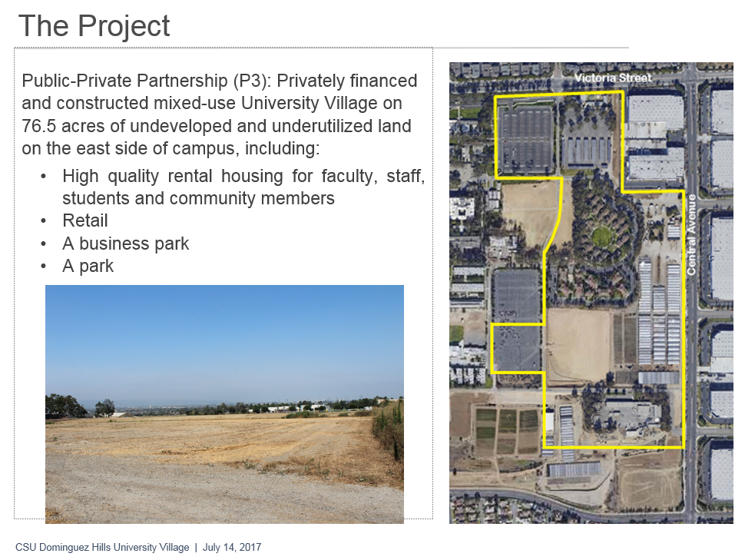
Goodwin said we started this process back in October 2015. There has been a lot of work that’s gone into it during this time. She commented that there were different models they looked at but it was necessary to determine if this market could sustain it and was viable. Part of this process included working through a CSUDH Steering Committee and eliciting feedback through open forums.

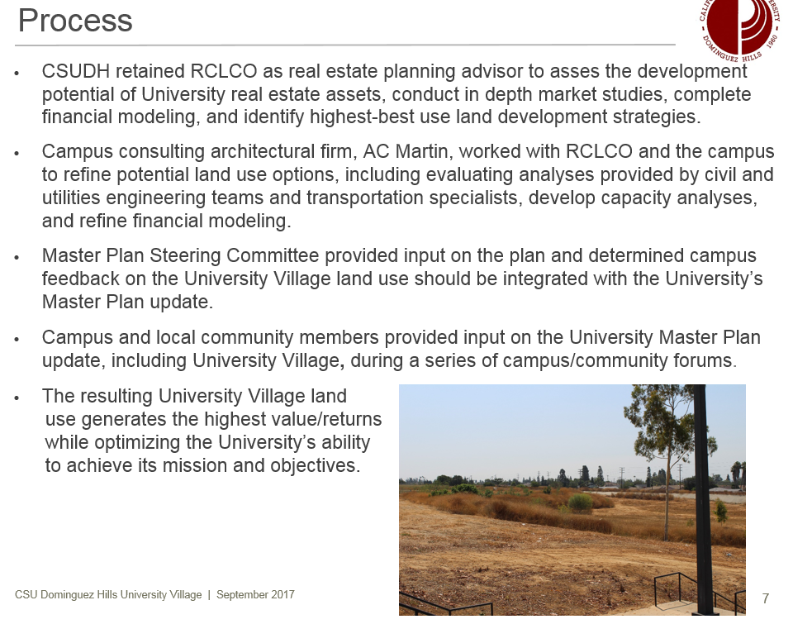
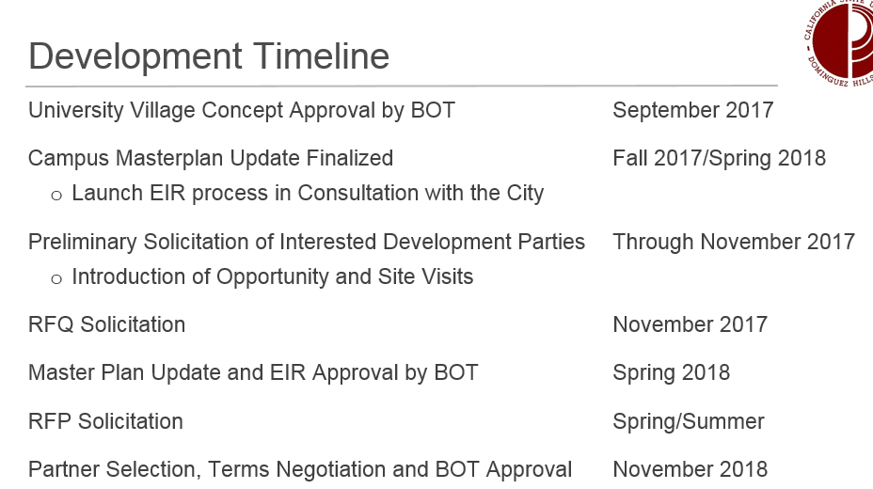

Q & A/Comments
Price asked if there was a community center being planned, how about child development expansion, and what about renewable energy, and has there been an AEG renegotiation. Goodwin responded that a community center is the first time that this suggestion has come up and can be looked into. It’s exactly this kind of feedback they hope to have. She said it should be something that connects with the campus, and we all feel good about, and as they move forward with the city of Carson, it might be something that would be of interest to them. With regard to the expansion of the child development center, that is something that as you look at the presentation, there is a plan in place to relocate the children’s center and it would be larger. The developer may look to a child development center as something they may wish to develop in the retail area. Sustainable development is part of our design guidelines. We want to make sure that this is a quality development. We will set the standards of what they want to achieve. With regard to the StubHub Center, we have engaged with them. We’ve made some progress. They understand where we’re coming from and we’re not giving away anything. We’re holding to the letter of the law relative to our existing agreement, and we have not secured a new agreement with them, but it’s not over yet. We’re continuing to engage with them. Senator Tsuno asked if there was public art component relative to the plan. Goodwin said that is also an excellent idea and when they met with the city of Carson, they’re actually looking to include a development that they’re going to have closer to the 405 freeway, a development that they’re working on. We didn’t get into that level of detail on this development, and it is something that we can put into the design guidelines moving forward. Celly suggested to confer with some of the experts on campus in terms of creating an urban eco-system with lots of green and trees; Celly said she’s hoping that is something that will be factored into the planning. Goodwin said we’re not looking for this to be an overdeveloped area, but there are nuanced things that can be done within a development to make if feel like the kind of community we all want to be a part of. Goodwin added there’s even been discussions like having rooftop gardens for example and perhaps having a farm. Senator McGlynn asked if an environmental impact review (EIR) has already been done. Goodwin said no, the draft EIR has not been released, we just have studies that inform the EIR. The EIR will be released in the next month. McGlynn said when the StubHub Center first came in, the mitigation site was not developed with the understanding that the campus had. This is a brand new opportunity to do some revegetation and restore some of the native habitat that will be both economically viable and attractive to people living there. He encouraged that Goodwin seek them out for input. Goodwin said she will do that for sure. Luckett asked if there were any discussion about mass transit possibilities. The Silver Line is only about a mile and a half away and would be a relatively low intensity impact to reroute that. Goodwin said as more people that are physically residing here and going to school here that will help to leverage for that argument. FPC Chair Avila thanked Goodwin and also wanted to acknowledge the amount of work that went into it. Avila said with new of the President’s retirement, she wondered about the continuity. How do we envision this exciting project is going continue with the next person? Goodwin responded that we are looking to have this approved by the Board of Trustees, and we’ll be going out with our request for proposals by the end of next spring. President Hagan will still be here and championing all of that. It’s something that has a lot of momentum behind it. President Hagan said the Board of Trustees (BOT) unanimously approved the concept plan. That means the BOT looked at the market analysis and how it relates to our strategic plan. The BOT have their own land development committee that studied and reviewed this particular project. Approving the viability was the first major step. Now we go to developers. Hagan said his goal was to get it on the rails, keeping in mind that it is a 7 - 10 year project, it has been approved and we’re just working our way through. Hagan concluded by saying the key decisions that still have to be made, he’ll still be here and lobbying on our behalf. Senator Radmacher said with regard to the child development center when it is moved and rebuilt, consulting with some of the departments on campus that it could potentially affect - it might be a good collaboration. A new child development center could also be a lab school that our students could go in and learn and utilize that space and would also be a benefit for the community and our students. Goodwin responded, “Definitely.” Talamante asked if there would be a community forum where you will also do this presentation to bring in our local community stakeholders as well as students and other faculty. Goodwin said we could absolutely do that specifically on the land development plan.
OPEN MIC
Chair Talamante informed everyone that we are not always at Loker Student Union and that at the October 11th meeting we will be at the Library, 5th Fl. South. Additionally, there had been a suggestion that the Senate work on our own form of appreciation in acknowledgement of service to shared governance. She said please look in your department mailboxes. In addition, while it is a token, it is a token given with sincere appreciation for all of the time and input that you bring to Senate business.
Meeting adjourned.

