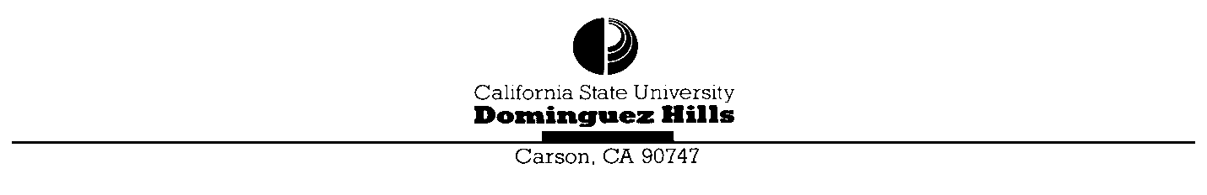
Department of Biology Graduate Program
NSM A-143 · 1000 E. Victoria St. · Carson CA 90747 · (310) 243-3381 · FAX (310) 243-2350

Departmental Application for Admission Masters of Science in Biology
All supporting documents must be received by the Department of Biology by April 1st for consideration for Fall entrance into the program or November 1st for Spring entrance. Send the following documents directly to the Department of Biology. You will also need to apply to the University, through Cal State Apply (calstate.edu/apply).
- Departmental Application for Admission
- Transcripts from each college attended
- Three letters of recommendation sent directly to the department
- A letter to the department describing interests, goals and expectations in pursuing the master’s degree in biology

Submitted __________________________________ for admission in ________________________________ Month Year Month Year
Have you previously filed the separate application to the University? No_______ Yes_______ If yes, what date?____________________
Are you presently a student at CSUDH? No____ Yes____ Undergraduate_____ Post baccalaureate_____

PERSONAL INFORMATION

__________________________________________________________________________________________ Last Name First Name Middle
__________________________________________________________________________________________ Mailing Address: Number Street City State ZIP
__________________________________________________________________________________________ Permanent Address: Number Street City State ZIP
__________________________________________________________________________________________ Home Phone Work Phone Date of Birth
__________________________________________________________________________________________ E-mail State of Legal Residency Citizenship

(over)
EDUCATIONAL INFORMATION
College or University Dates Attended Major Degree G.P.A. __________________________________________________________________________________________ __________________________________________________________________________________________ __________________________________________________________________________________________ __________________________________________________________________________________________
G.P.A. for all college work __________________ G.P.A. for all Science and Math classes__________________
G.P.A. should be computed on the following scale: A=4 points, B=3 points, C=2 points, D=1 point, F=0 points. Plus (+) and minus ( –) designations are not computed. This must be accompanied by transcripts from all colleges attended.
WORK EXPERIENCE
Most recent occupation(s) other than student:
Occupation Employer Dates
__________________________________________________________________________________________ __________________________________________________________________________________________ ____________________________________________________________________________________________________________________________________________________________________________________
REFERENCES
List below the names and address of three references who know your academic qualifications well enough to evaluate your potential for graduate work and a future in biology. Each of these people should send a letter of recommendation to the Department of Biology by April 15th for consideration for Fall entrance into the program or November 15th for Spring entrance.
Name Title Relationship to Applicant
__________________________________________________________________________________________ __________________________________________________________________________________________ __________________________________________________________________________________________
References should send these letters directly to: CSUDH Department of Biology, Graduate Program, NSM A-143, 1000 E. Victoria St., Carson, CA 90747. Alternatively, references could email their letters directly to biology@csudh.edu.
List the CSUDH Biology faculty you are interested in working with. __________________________________________________________________________________________ ____________________________________________________________________________________________________________________________________________________________________________________
Please send this application and all the supporting documentation to:
CSUDH Department of Biology Graduate Program NSM A-143 1000 E. Victoria St. Carson, CA 90747

